CSS GENDER STUDIES
T1KB
The Knowledge Base
Topic 1 · Gender Studies and the Social Construction of Gender — the discipline, and the idea at its heart, taught from zero
WHAT THIS DOCUMENT GIVES YOU
◆ Syllabus Heads I and II taught from zero in simple English — every term explained
◆ The discipline — its birth, its difference from Women's Studies, its many disciplines, the autonomy–integration debate and its state in Pakistan
◆ The social construction of gender — its history, its theories, queer theory, masculinities and femininities, nature versus culture, gendered language and the transgender debate
◆ Evidence inside every point, 16 diagrams, contemporary debates and five likely questions
◆ A one-liner bank, every past MCQ on the topic, and a revision sheet
Federal Public Service Commission · CSS Competitive Examination · Optional paper, 100 marks
Written for CE-2027 onwards · Record: CE-2016 to CE-2026 · Facts current to September 2026

Contents
HOW TO BUILD THE CONTENTS
The contents list below fills itself in. When Word asks "This document contains fields that may refer to other files. Update the fields?", click Yes.
If it does not ask: right-click the grey contents area → Update Field → Update entire table → OK. On a Mac, Control-click the same area. Or press Ctrl + A, then F9 (Windows), to update every field at once. Repeat after any edit, before you export to PDF.

Right-click here and choose Update Field to build the contents.

How to Use This Document

What this topic covers
Topic 1 is the foundation of the whole subject. It joins two syllabus heads. The examiner treats them as one family.
- Head I — Introduction to Gender Studies: what Gender Studies is; how it differs from Women's Studies; why it uses many disciplines; the autonomy versus integration debate; and the state of Gender Studies in Pakistan.
- Head II — Social Construction of Gender: the history of the idea that gender is "made"; queer theory and the question "is sex made by society too?"; masculinities and femininities; and the nature versus culture debate.
The topic also teaches three things the examiner has asked that the syllabus does not name: gendered language (2020), the many meanings of the word "gender" (2020), and the transgender law of 2018 and its court case (2026).
This is the second-heaviest topic in the record: 16.5 visits in eleven papers. Four families of questions — Women's vs Gender Studies; the many disciplines; autonomy vs integration; the field in Pakistan — have been asked fourteen times between them. If you master this topic, you will find at least one strong question in almost every paper.

How this document is built
1. Part Zero gives you the words of the topic and a one-page picture of it.
2. Part One has eleven chapters. Chapters 1–5 teach the discipline (Head I). Chapters 6–11 teach the social construction of gender (Head II).
3. Part Two sets out today's debates on the topic.
4. Part Three lists every past question, what the record shows, and five likely questions.
5. Part Four is a bank of 120 numbered one-liners, written in the style of the past MCQs.
6. Part Five is the revision sheet — the whole topic in a few pages, with every word explained, for the night before the exam.
Evidence always sits inside the point it proves. A definition card is teal, a thinker card plum, a data card blue, a law card navy and a case card coral. Each card ends with an arrow (➜) that says what the evidence proves.
IN SIMPLE WORDS
Read Chapters 1–5 as one story: how a new subject was born and how it lives in Pakistan. Read Chapters 6–11 as a second story: how one big idea — that gender is made, not born — was found, argued over and applied.

Part Zero — The ABC of Topic 1

0.1 The words of this topic
Table 1 · The key terms of Topic 1 (★ = you must be able to define it in one sentence).
Term | Simple meaning, with an example
Sex ★ | The body differences between females and males: chromosomes, hormones and organs. Only women can give birth.
Gender ★ | The roles, behaviour and power that society gives to being female or male. The belief that only mothers should raise babies.
Gender Studies ★ | The study of how society makes gender, how gender shares out power, and how it mixes with class, religion and other identities.
Women's Studies ★ | The field, started around 1969–70, that puts women at the centre of study.
Men's / masculinity studies | The study of men as gendered people — how "manhood" is made and what it costs.
Discipline | A recognised branch of knowledge with its own subject, methods, departments and journals.
Multidisciplinary ★ | Using several disciplines side by side to study one subject.
Interdisciplinary | Mixing the methods of several disciplines into one new approach.
Autonomy ★ | Keeping Gender Studies as a separate department with its own staff and degrees.
Integration ★ | Adding gender to every subject — law, medicine, economics and so on. Also called mainstreaming.
Androcentrism ★ | Treating men as the normal human and women as the exception.
Patriarchy ★ | A system in which men hold most power and this is treated as natural.
Essentialism ★ | The view that women and men have a fixed, natural nature.
Social constructionism ★ | The view that things which look natural are really made by society.
Socialisation ★ | Learning society's rules, including gender rules, from family, school, media and religion.
Gender role ★ | The behaviour society expects of each gender. Men as breadwinners.
Gender identity ★ | A person's inner sense of being a woman, a man, both or neither.
Gender stereotype | A fixed, over-simple belief about a gender. "Women are emotional."
Femininity / masculinity ★ | The qualities society expects of women / of men.
Hegemonic masculinity ★ | Connell's term for the most honoured way of being a man, which supports men's power over women and over other men.
Emphasised femininity | Connell's term for the kind of femininity built around pleasing and serving men.
Androgyny | Having both "masculine" and "feminine" traits (Sandra Bem, 1974).
Queer theory ★ | A theory (from about 1990) that questions fixed boxes of sex, gender and sexuality.
Heteronormativity | The assumption that there are only two opposite genders and that only heterosexuality is normal.
Performativity ★ | Judith Butler's idea that gender is created by repeated acts, not by an inner core.
Intersex | Born with a body that does not fit the usual male or female pattern. Islamic law calls such a person khuntha.
Transgender / khawaja sira ★ | A person whose gender identity differs from the sex recorded at birth. Khawaja sira is the traditional South Asian term.
Nature versus culture ★ | The debate over whether gender differences come from biology or from upbringing and society.
Biological determinism | The belief that biology alone decides behaviour and roles.
Deconstruction | Taking an idea apart to show its hidden assumptions and rankings (Jacques Derrida).
Gendered language ★ | Language that carries gender bias in its words, grammar or use. "Chairman", "mankind".

0.2 The one distinction that starts everything
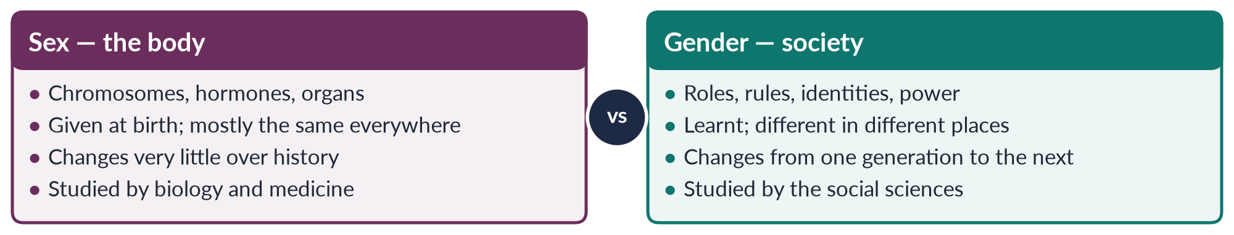
Figure 1 · Sex and gender: the distinction on which the whole subject rests.
For fifty years this table has been the first thing every student of the subject learns. Topic 1 teaches you to use it. Then, in Chapter 8, it teaches you to question it, because some thinkers argue that even the left-hand column is partly shaped by society.

0.3 Topic 1 on one page
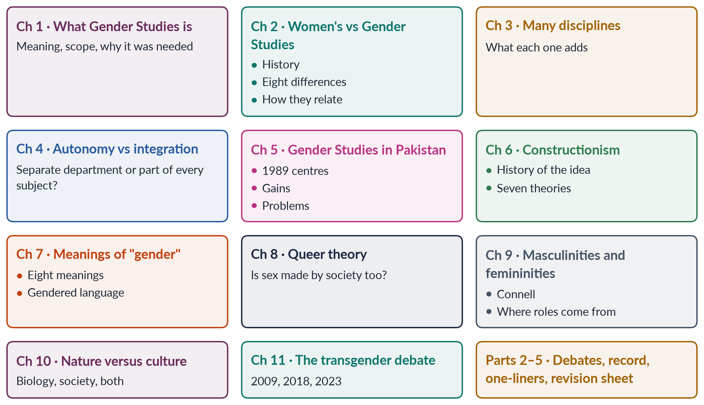
Figure 2 · Topic 1 on one page: eleven chapters, two stories.
EXAMINER'S EYE · HOW THE EXAMINER USES THIS TOPIC
The examiner asks the discipline half (Chapters 1–5) as "define and differentiate" and "write a note / give your views" questions. He or she often joins two families in one question — for example, the field in Pakistan plus autonomy versus integration. The construction half (Chapters 6–11) is asked as theory: "what are the theories…", "deconstruct…", "natural or social?" and, most recently, theory applied to Pakistani law. Learn each chapter so that it can stand alone and be joined to another.

Chapter 1 · What Gender Studies Is
Before you compare Gender Studies with anything, you must be able to say what it is, what it studies, what it wants, and why the world needed it. That is this chapter.

1.1 Defining Gender Studies
✦ DEFINITION
Gender Studies · the exam definition
Gender Studies is the academic field that studies how society makes femininity and masculinity, how this shares out power, money and chances between women, men and gender-diverse people, and how gender mixes with class, religion, race, age, disability and sexuality. It uses the tools of many disciplines.
➜ Learn this definition. It holds the four ideas the examiner looks for: society makes gender; gender is about power; the field uses many disciplines; gender mixes with other identities.

Each part of the definition can become a heading of an answer:
1. It is an academic field. It has departments, degrees, journals and research methods. It is not just a slogan, although it has close links with the women's movement.
2. It studies how gender is made. Its starting point is that gender is made by society, not simply given by nature (Chapters 6–10).
3. It studies power. It asks who gains and who loses from the way gender is arranged — at home, at work, in politics, in religion and in law.
4. It studies everyone. Women, men, and people who do not fit into two boxes — and the relations between them.
5. It uses many disciplines. Sociology, psychology, anthropology, history, economics, politics, law, biology and literature (Chapter 3).
6. It sees overlaps. Gender never works alone. A poor village woman and a rich city woman do not live the same "womanhood". This idea is called intersectionality.
IN SIMPLE WORDS
Gender Studies asks three questions about any part of life: What do we expect from women and from men here? Where did these expectations come from? Who gains, who pays, and how could it be fairer?

1.2 What Gender Studies studies — its scope
Gender touches every part of life, so the field is wide. Its main areas are:
- Identity and the body: how people come to see themselves as women, men or otherwise; sexuality; health and childbirth.
- Family and home: marriage, housework, care, inheritance, and violence at home.
- Work and the economy: paid and unpaid work, the pay gap, informal work, development.
- Politics and the state: voting, representation, law and policy.
- Culture and knowledge: religion, language, media, literature and education.
- Violence and security: gender-based violence, war and peace-building.
- Global changes: colonialism, globalisation, migration and climate change.
EXAMPLE · ONE ISSUE, MANY ANGLES
Take child marriage in Pakistan. Gender Studies asks about identity (how girls learn what a "good daughter" is), family (why parents marry daughters early — poverty, "honour", dowry), economy (the girl's lost schooling and earnings), law (the Child Marriage Restraint Act of 1929; Sindh's law of 2013; Islamabad's law of 2025), religion (the debate in the Council of Islamic Ideology), health (early pregnancy and deaths in childbirth) and power (who decides). No older subject asked all these questions together.

1.3 The aims of Gender Studies
1. To make the invisible visible — to show where women, and gender, had been left out of knowledge.
2. To explain inequality — to find its causes, not only describe it.
3. To question what looks "natural" — to test whether roles that seem natural are really social and changeable.
4. To produce better knowledge — knowledge that includes the experience of half of humanity.
5. To guide policy — to give governments, courts and aid agencies the evidence they need.
6. To empower — to support the struggle for equality. Joining study with action is called praxis.

1.4 Why the discipline was needed
The older disciplines had four blind spots. This section answers the 2019 question that asked you to "trace the need for the establishment of Gender Studies as a distinct discipline".

(1) Knowledge treated men as the normal human
For centuries, knowledge was androcentric — it treated men's lives as human lives. History was the story of kings and generals. Medicine tested medicines mostly on men. Psychology built its theories of moral growth by studying boys. When Carol Gilligan (In a Different Voice, 1982) studied girls, she found an "ethic of care" that the old theory had wrongly ranked as weaker.

(2) Women's work was not counted
✦ THINKER
Marilyn Waring · New Zealand economist and former MP · *If Women Counted* (1988)
Waring showed that the United Nations system for measuring a country's income (GDP) counted a woman's work only when she was paid for it. Cooking, cleaning, caring for children and the old, fetching water and growing food for the family were "not work".
➜ Economics had made most of women's labour invisible — so the policies built on it were blind too.

(3) The women's movement asked questions no one could answer
In the 1960s the women's movement asked: Why do women earn less? Why is violence at home ignored? Why do so few women hold power? The universities had no courses, no data and no theories to answer. Women's Studies was created as "the academic arm of the women's movement".

(4) "Adding women" was not enough
The first step was to "add women and stir" — a chapter on women in a history book, a class on women in a development course. This left the old assumptions untouched. A new field was needed that questioned the frameworks themselves and later studied men and gender relations too. That field became Gender Studies (Chapter 2).
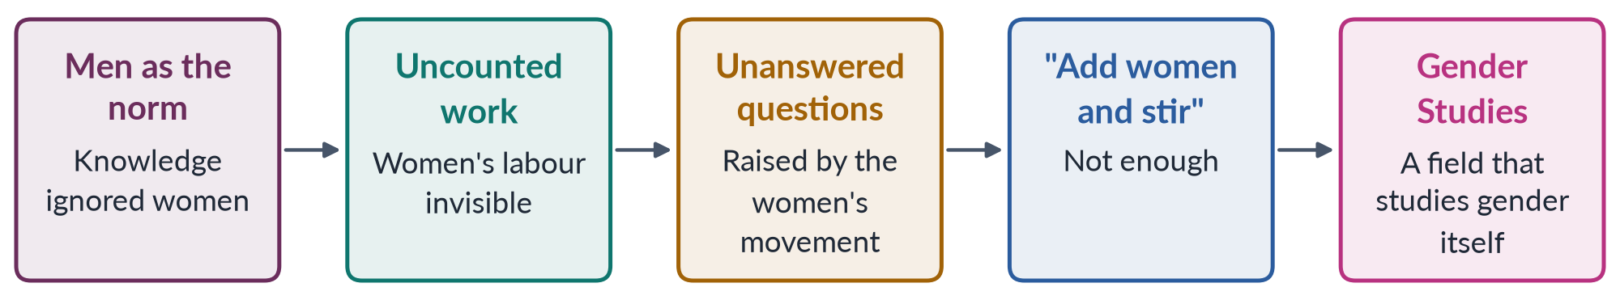
Figure 3 · Why a separate discipline was needed: four blind spots produced a new field.

1.5 The main features of the discipline
- It uses many disciplines, and mixes them (Chapter 3).
- It is committed. It openly aims at justice. Critics call this bias; supporters call it relevance.
- It questions who makes knowledge. Feminist researchers try to do research with women, not just on them.
- It looks at overlaps. Since the 1980s it studies how gender mixes with class, race, caste, religion and disability.
- It compares societies. Comparison shows that gender differs from place to place — so it is not fixed.
✦ THINKER
Joan Wallach Scott · American historian · "Gender: A Useful Category of Historical Analysis" (1986)
"Gender is a constitutive element of social relationships based on perceived differences between the sexes, and gender is a primary way of signifying relationships of power."
➜ In simple words: gender is one of the main ways a society shows and justifies who has power. That is why a whole discipline is built on it.

1.6 Why Gender Studies matters — especially for Pakistan
PAKISTAN ANGLE · WHY PAKISTAN NEEDS THIS DISCIPLINE
• International promises: Pakistan joined CEDAW (the UN women's rights treaty) in 1996 and promised to reach SDG 5 (gender equality) by 2030. Both need gender data, analysis and trained officials.
• Development: Pakistan ranked 143rd of 145 in the Global Gender Gap Report 2026. To close the gap we must understand why only 24.4% of working-age women are in the labour force (Labour Force Survey 2024–25) and why women's literacy is only about 53% (Census 2023).
• Law: many pro-women laws have been passed since 2004. People trained in Gender Studies staff the commissions, protection centres and NGOs that put them into effect.
• Good government: gender budgeting and gender-aware planning need the skills this field teaches.
• Social change: the field gives society words — "gender", "harassment", "consent", "care work" — to discuss problems that were once hidden at home.

EXAMINER'S EYE · THE "SIGNIFICANCE" ANSWER IN FOUR HEADINGS
When a question asks for "scope and significance", give one heading to each kind of significance: academic (complete knowledge; new methods), policy (CEDAW, SDGs, gender budgeting), social (awareness; changing attitudes) and Pakistani (data, laws, institutions). Four headings, each with one piece of evidence, make a full answer to that part.

Chapter 2 · From Women's Studies to Gender Studies
The examiner asked you to "differentiate between Gender Studies and Women's Studies" in 2017, 2018, 2019 and 2023. To do it well you need the history of both fields, clear differences on named points, examples, and a view on how the two relate.

2.1 The birth of Women's Studies
Women's Studies was born in American universities in the late 1960s. It grew out of the second wave of the women's movement.
- In 1969 Cornell University offered one of the first courses on women.
- In 1970 San Diego State College started the first full Women's Studies programme.
- By the mid-1970s there were hundreds of courses. In 1977 the National Women's Studies Association was founded in the USA.
- Britain, Canada, Australia and Western Europe followed in the 1970s.
✦ CASE
India's Women's Studies movement · the South Asian beginning
In India, a government report called Towards Equality (1974) showed how little women's lives had improved since independence. The same year, SNDT Women's University in Bombay set up a research unit on women. The Indian Association for Women's Studies was formed in the early 1980s.
➜ In South Asia, Women's Studies grew from government concern as well as from activism. Pakistan followed a similar path in 1989 (Chapter 5).

From the start, Women's Studies had three features:
1. Women as the subject — the field studied women's history, work, writing, health and experience.
2. Women as the knowers — research was done by women, using women's own accounts.
3. Women as the beneficiaries — knowledge was meant to improve women's lives. Its founders called it "the academic arm of the women's movement".

2.2 How and why Women's Studies became Gender Studies
From the 1980s many programmes changed their name to "Gender Studies" or "Women's and Gender Studies". Five changes caused this:
1. The idea of "gender" grew up. Ann Oakley (1972), Gayle Rubin's "sex/gender system" (1975) and Joan Scott's essay (1986) showed that the real subject was a relationship between women and men, not women alone.
2. Men began to be studied. Scholars such as Raewyn Connell (Gender and Power, 1987) showed that men are gendered too, and that "manhood" has costs as well as benefits.
3. Queer theory arrived (about 1990). It brought gay, lesbian, transgender and intersex people into the field.
4. The single idea of "woman" was questioned. Black women, working-class women and women of the Global South said that Women's Studies had described the lives of white, middle-class Western women as if they were every woman's life (bell hooks, 1981; Chandra Talpade Mohanty, 1984).
5. Aid agencies changed their language. In the 1980s they moved from "Women in Development" to "Gender and Development" (Topic 4). Universities followed the money and the words.
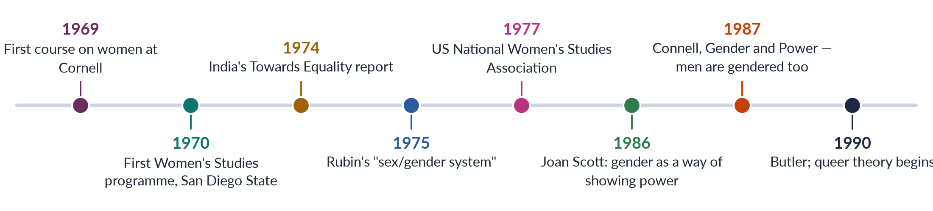
Figure 4 · From Women's Studies to Gender Studies.

2.3 The main differences
Table 2 · Women's Studies and Gender Studies compared on eight points.
Point | Women's Studies | Gender Studies
Subject | Women: their lives, work, history, writing, bodies | Gender relations: women, men and gender-diverse people, and the relations between them
Key idea | "Woman" and women's oppression | "Gender" as something society makes, and as a relation of power
Origin | The women's movement, late 1960s | Gender theory, men's studies and queer theory, 1980s–1990s
Aim | Make women visible and end their subordination | Explain how gender is made and how it shares out power for everyone
Politics | Openly feminist and woman-centred | Feminist roots, but wider; includes men and sexualities
Whose view | Research by and for women, from women's experience | Research from many viewpoints, including men's
Theories used | Liberal, radical and socialist feminism | Adds social constructionism, queer theory and intersectionality
Institutions | Women's Studies centres (Pakistan's centres of 1989) | Departments of Gender Studies (most Pakistani universities today)

EXAMPLE · THE SAME PROBLEM, STUDIED TWO WAYS
Honour killing. A Women's Studies approach puts the victims at the centre: the women killed, their families' accounts, the failure of police and courts to protect them. A Gender Studies approach adds the men and the system: how ideas of ghairat (honour) and manhood are taught to boys, why brothers and fathers kill, how families and jirgas bargain over "forgiveness", and how the law let killers escape until the 2016 amendment.
➜ Women's Studies asks "what happens to women?" Gender Studies also asks "what makes men do this, and what system connects them?"

EXAMPLE · A SECOND EXAMPLE: HEALTH IN CHILDBIRTH
Women's Studies records women's own experience of pregnancy, childbirth and neglect. Gender Studies also studies how husbands and mothers-in-law decide whether a woman may visit a clinic, how male doctors hold authority, and how a health budget set mostly by men chooses its priorities.

2.4 What the two fields share
- Feminist roots. Both grew out of the women's movement and share its aim of equality.
- A critique of male-centred knowledge. Both reject knowledge that treats men as the human norm.
- Many disciplines. Both use the tools of many subjects.
- An aim of change. Both want to guide policy and improve lives.

2.5 How they relate — rivals or partners?
There are three views:
1. Growth. Gender Studies is the grown-up form of Women's Studies: the same project with a better idea.
2. Dilution. Critics warn that the word "gender" can hide women again. The American critic Tania Modleski called her 1991 book Feminism Without Women to warn that some "gender" theory was losing sight of real women's suffering. In aid work, "gender" sometimes became a technical word that avoided talking about male power.
3. Partnership. Most scholars now see the two as partners. Many departments are called "Women's and Gender Studies" to keep both the focus on women and the study of relations.
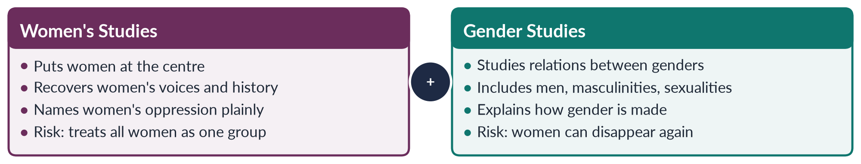
Figure 5 · Women's Studies and Gender Studies: two lenses on one project.
BALANCED VIEW · THE LINE TO TAKE IN THE EXAM
State the differences clearly. Then conclude that the two fields are stages and partners of one project: Women's Studies made women visible; Gender Studies explained the system that had made them invisible. In Pakistan, where basic facts of women's lives — literacy, health, work, violence — still need urgent attention, a focus on women remains essential, inside a gender framework that also studies men and power.

TRAP · THREE COMMON MISTAKES
• Saying Gender Studies "replaced" Women's Studies. It grew out of it, and the two exist side by side.
• Saying Gender Studies is "against men" or "only about women". It studies men and masculinities too.
• Forgetting examples. The 2018 question said "substantiate your argument(s) with examples". Give at least two.

Chapter 3 · The Multidisciplinary Nature of Gender Studies
Asked as a full question in 2022 and as the second part of a question in 2023. The winning answer defines the terms clearly, then shows — discipline by discipline — what each one adds, with a thinker and an example.

3.1 Three words that are often confused
Table 3 · Multi-, inter- and trans-disciplinary.
Term | Simple meaning | Gender Studies example
Multidisciplinary ★ | Several disciplines study one subject side by side, each with its own methods | A course on violence where a sociologist, a lawyer and a psychologist each give lectures
Interdisciplinary | The methods of several disciplines are mixed into one approach | "Feminist economics" mixes economics with gender theory to measure unpaid care work
Transdisciplinary | Work that goes beyond the university, often with non-academic partners | Researchers, activists and survivors designing a programme against violence together

Gender Studies began as multidisciplinary — a set of courses from many departments. It has become more and more interdisciplinary, with its own mixed ideas such as the "care economy", "intersectionality" and "gender budgeting".

3.2 Why the field has to use many disciplines
1. Gender is everywhere. It shapes bodies, minds, families, markets, laws, religions and languages. No single discipline covers them all.
2. Its problems are complex. Why do so few Pakistani women work outside the home? The answer needs economics (jobs and wages), sociology (family rules), law (harassment and maternity rights), geography (transport), psychology (fear and safety) and politics.
3. Its founders came from many subjects. The first Women's Studies teachers came from English, history, sociology and psychology and brought their methods with them.
4. It studies knowledge itself. To show that a discipline is male-centred, you must work inside it.

3.3 What each discipline adds
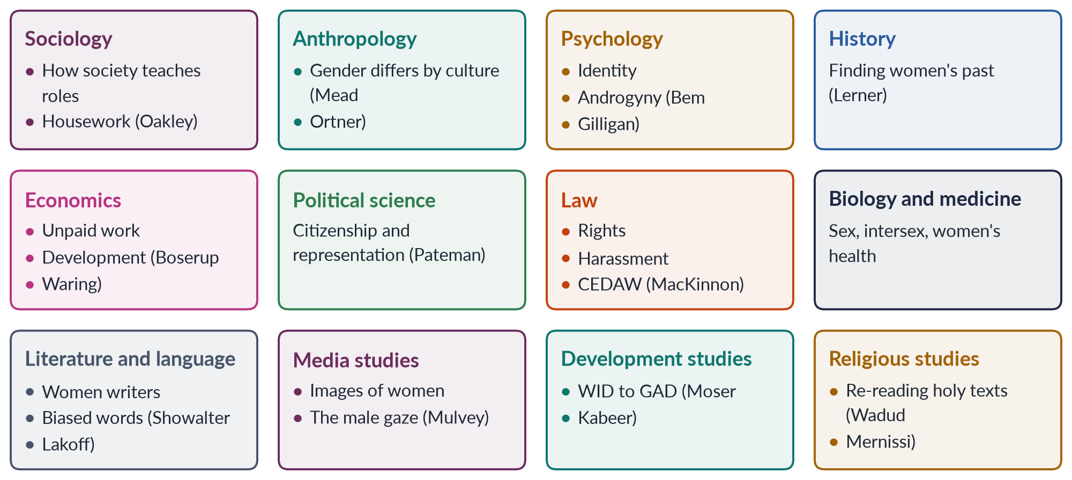
Figure 6 · The disciplines that feed Gender Studies, with one contribution each.

(1) Sociology
Sociology gives Gender Studies its core idea: social arrangements are made by people. Ann Oakley (The Sociology of Housework, 1974) showed that housework is real work — boring, tiring and unpaid. Sociologists study socialisation, the family, the division of labour and inequality. Pakistan: studies of how purdah rules limit women's movement in rural Punjab and Khyber Pakhtunkhwa.

(2) Anthropology
Anthropology proved that gender changes from culture to culture. Margaret Mead (1935) found gentle men and women among the Arapesh, fierce men and women among the Mundugumor, and bossy women among the Tchambuli. Sherry Ortner (1974) asked why women are linked with "nature" and men with "culture". Michelle Rosaldo (1974) linked women's lower status to their being kept in the home. Pakistan: studies of kinship, exchange marriage (watta satta) and honour.

(3) Psychology
Psychology studies how gender identity forms in the mind. Freud's theories were later challenged by feminists (Topic 2). Sandra Bem (1974) measured androgyny — having both "masculine" and "feminine" traits. Carol Gilligan (1982) found an "ethic of care" in girls. Psychology also studies stereotypes, mental health and the effects of violence. Pakistan: research on depression among women and the mental effects of violence at home.

(4) History
History finds the women left out of the record — sometimes called "her-story" — and shows that gender arrangements change. Gerda Lerner (The Creation of Patriarchy, 1986) traced how male rule began in the ancient Middle East. If patriarchy had a beginning, it can have an end. Pakistan: recovering women's roles in the Pakistan Movement — Fatima Jinnah, Begum Jahanara Shahnawaz, Begum Ra'ana Liaquat Ali Khan.

(5) Economics
Economics shows how gender shapes work, income and development. Ester Boserup (Woman's Role in Economic Development, 1970) showed that development projects ignored women farmers. Marilyn Waring (1988) showed that GDP ignores unpaid work. Feminist economics now measures care work through "time-use" surveys. Pakistan: only 24.4% of working-age women are in the labour force (LFS 2024–25); the pay gap; women who work from home.

(6) Political science
Political science studies power, the state and citizenship. Carole Pateman (The Sexual Contract, 1988) argued that the famous "social contract" of liberal thinkers rested on a hidden contract that placed women under men. The discipline studies representation, quotas and women's movements (Topic 6). Pakistan: the 60 reserved seats for women in the National Assembly and what they have achieved.

(7) Law
Law turns gender analysis into rights. Catharine MacKinnon (Sexual Harassment of Working Women, 1979) argued that sexual harassment is a form of sex discrimination — an idea that became law in many countries. Feminist legal study shows how "neutral" laws can affect women and men differently. Pakistan: the Constitution (Articles 25 and 34); the Protection against Harassment of Women at the Workplace Act 2010; the debate over the Hudood Ordinances (Topic 5).

(8) Biology and medicine
Biology gives the facts of sex difference — and, as Chapter 8 shows, evidence that bodies are more varied than two neat boxes. Medicine studies women's health, which was long neglected. Pakistan: 186 mothers die per 100,000 live births (Pakistan Maternal Mortality Survey 2019); anaemia; the health of intersex people.

(9) Literature, language and media
Literary studies bring back forgotten women writers (Elaine Showalter's "gynocriticism") and study how books show gender. Linguistics shows how language carries bias (Robin Lakoff, 1975; Chapter 7). Media studies look at images of women; Laura Mulvey (1975) described the "male gaze" of cinema — films shot as if for a male viewer. Pakistan: women writing in Urdu (Ismat Chughtai, Fahmida Riaz, Kishwar Naheed) and the way television dramas and adverts show women.

(10) Development studies and religious studies
Development studies built the WID, WAD and GAD approaches (Topic 4). Religious studies re-read holy texts from a woman's point of view — for example Amina Wadud (Qur'an and Woman, 1992) and Fatima Mernissi. Pakistan: the Benazir Income Support Programme, which pays women directly; debates in the Council of Islamic Ideology.
IN SIMPLE WORDS
Think of Gender Studies as a meeting room. Each discipline brings its own tools to the same table: the sociologist brings surveys, the anthropologist brings field notes, the lawyer brings laws, the economist brings statistics. Gender Studies is the conversation between them.

3.4 Strengths and weaknesses of using many disciplines
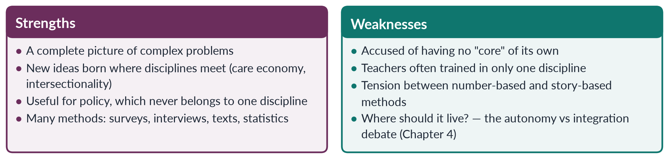
Figure 7 · The two sides of using many disciplines.
EXAMINER'S EYE · HOW TO END A "MULTIDISCIPLINARY" ANSWER
End by linking the many disciplines to the autonomy versus integration debate. Because gender belongs to every discipline, some argue it should be added to all of them (integration). Because the field has built its own ideas and methods, others argue it needs a separate home (autonomy). This link shows the examiner you understand the field as a whole — and it is exactly how the 2023 question joined its two parts.

Chapter 4 · The Autonomy versus Integration Debate
The examiner's favourite question from Head I: asked in 2016, 2017, 2021 and 2023. You need the origin of the debate, the case for each side, the risks of each, how the debate is settled, what it gave the field — and your own view for Pakistan.

4.1 What the debate is about
As Women's Studies grew in the 1970s, its founders faced a practical question with big consequences: where should the new knowledge live?
✦ DEFINITION
Autonomy · the separate-department plan
Women's (or Gender) Studies as an independent unit — its own department, teachers, courses, degrees, budget and research.
➜ In simple words: autonomy means building a house of your own. Example: a Department of Gender Studies that awards its own BS and PhD degrees.

✦ DEFINITION
Integration · the "in every subject" plan
Adding women and gender to every existing subject — history, economics, law, medicine and the rest — through new topics, readings and ways of looking. It is also called mainstreaming.
➜ In simple words: integration means changing everyone else's house. Example: a law degree that teaches women's inheritance rights, or a medical degree that teaches maternal health properly.

✦ THINKER
Gloria Bowles and Renate Duelli Klein · editors · *Theories of Women's Studies* (1983)
Their introduction, "Theories of Women's Studies and the Autonomy/Integration Debate", set out the debate for the whole field. They argued that integration without a separate base would water down feminist study, so Women's Studies needed its own space to build its own theory — while also working to change other subjects.
➜ The classic answer is not "one or the other". Its founders wanted a strong separate base from which integration could go forward.

This book is on the FPSC reading list (items 1 and 2). That is one reason the examiner returns to the debate so often.

4.2 The case for autonomy
1. Room to create new knowledge. New theories and methods need a place where they are the main business, not an extra.
2. Depth. Students can study gender for a whole degree, MPhil or PhD — not in a single lecture.
3. Protection. Inside other departments, gender topics can disappear when a friendly teacher leaves or a hostile head arrives.
4. Respect and visibility. A department with degrees, budgets and journals shows that the field is serious.
5. A critical voice. An independent unit can criticise the male bias of other subjects without depending on them.
6. A home for people. It gives researchers, students and activists a base, and links the university with the women's movement.

4.3 The case for integration
1. Gender matters to every subject. Economics without unpaid work, medicine without women's bodies and law without gender are incomplete. Every subject must change.
2. It reaches every student. A Gender Studies department teaches a few hundred students. Integration reaches every future doctor, engineer, lawyer and civil servant.
3. It avoids the "ghetto". A separate department can be seen as a small "women's corner" that others ignore.
4. It changes the subjects themselves. The final goal is not a separate "women's knowledge" but better knowledge for all.
5. It is cheaper. Poor universities may not afford new departments.
6. It involves men as teachers and students, instead of leaving gender to women.

4.4 The risks of each plan
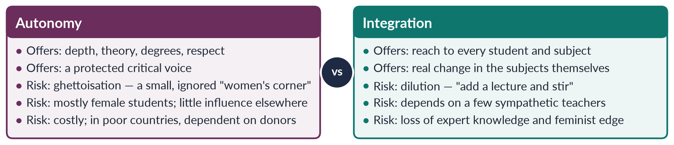
Figure 8 · Autonomy and integration: what each offers and what each risks.
Two words sum up the risks:
- Ghettoisation — the risk of autonomy. The field is pushed into a corner: separate, small, mostly female, and ignored by everyone else.
- Dilution — the risk of integration. Gender is watered down into one token lecture, and the deep analysis is lost.
IN SIMPLE WORDS
Autonomy is like building a specialist hospital: great expertise, but patients must travel to it. Integration is like training every family doctor: wide reach, but few real experts. A health system needs both — and so does knowledge.

4.5 How the debate is settled — the dual strategy
The debate is usually settled not by choosing one side but by combining both. In the dual strategy (also called "both–and"), a separate centre:
- trains specialists and produces research and theory; and
- works outward to bring gender into other departments — training their teachers, sharing their courses and designing gender modules for them.
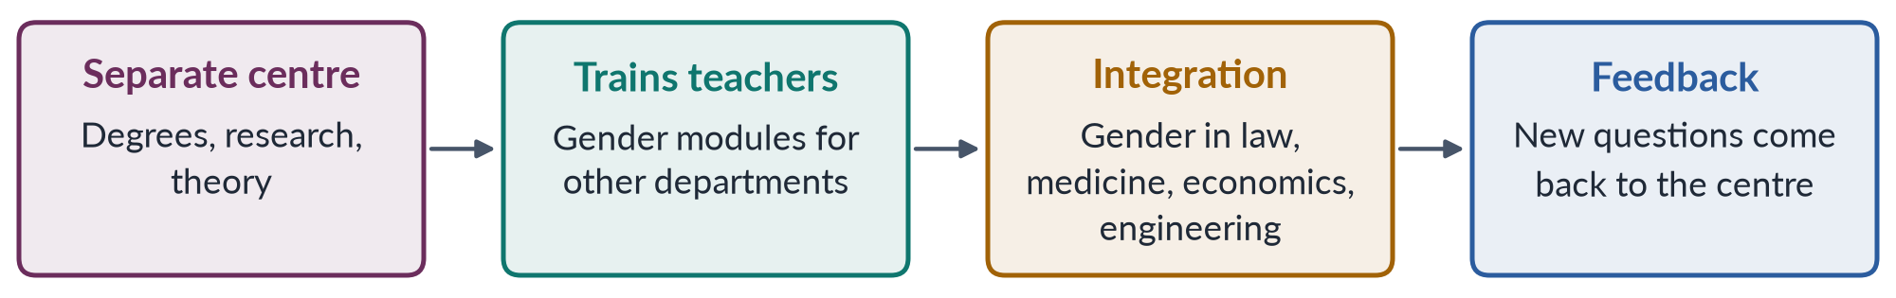
Figure 9 · The dual strategy: a separate base drives integration.
The same idea later shaped world policy. The Beijing Platform for Action (1995) adopted gender mainstreaming — checking every policy for its effect on women and men (integration) — while also keeping special programmes and separate women's ministries (autonomy). This "twin-track" approach is the government version of the dual strategy.

4.6 What the debate gave the field
The 2021 question asked how the debate "made an important contribution to the development of the field of knowledge". It helped the field in six ways:
1. It clarified what the field is. Arguing about where Women's Studies belonged forced scholars to define it: both a subject of its own and a critique of all knowledge.
2. It produced feminist epistemology — the study of how we know. Sandra Harding (The Science Question in Feminism, 1986) asked whether traditional science was truly "objective" or shaped by the viewpoint of the men who made it.
3. It built institutions. The case for autonomy won departments, degrees, journals and professional associations.
4. It changed the curriculum. The case for integration produced "curriculum transformation" projects in the 1980s, which rewrote courses in history, literature, sociology and medicine.
5. It gave governments a model. The dual strategy became the model for gender mainstreaming in governments and aid agencies.
6. It taught the field to question itself. Constantly asking "are we being pushed aside, or swallowed up?" made the field self-critical. This helped it listen to Black, postcolonial and queer critics later.
EXAMINER'S EYE · THE STRUCTURE THE EXAMINER REWARDS
For a "write a note / give your views" question: 1. Introduction and definitions; 2. Origin (Bowles and Klein, 1983); 3. The case for autonomy; 4. The case for integration; 5. The risks of each; 6. The dual strategy; 7. Pakistan; 8. Your view and conclusion. For the 2021 angle, make the six contributions of the debate your main headings.

4.7 The debate in Pakistan
PAKISTAN ANGLE · AUTONOMY AND INTEGRATION IN PAKISTANI UNIVERSITIES
• Autonomy came first. In 1989 the federal government created Women's Studies centres in five universities (Chapter 5). Today many universities have Gender Studies departments with BS, MPhil and PhD degrees.
• Integration is weak. Most students of law, medicine, economics, engineering and education never take a gender course. How textbooks show women is a regular controversy.
• The risks are visible. Centres depend on donor projects, are staffed and attended mostly by women, and have little influence on the rest of the university — a form of ghettoisation.

BALANCED VIEW · YOUR VIEW FOR PAKISTAN
Pakistan needs both. It needs strong separate departments to train specialists and produce local research, because the field is young and short of trained teachers. And it needs deliberate integration of gender into the courses that shape the country's professionals — medicine (maternal health), law (family and criminal law), economics (unpaid work), education (textbooks) and civil-service training. Integration without autonomy would lack experts. Autonomy without integration would leave the field in a corner. The dual strategy is not a compromise — it is the only plan that works.

Chapter 5 · Gender Studies in Pakistan
"The status of Women's / Gender Studies in Pakistan" has been asked four times (2016, 2018, 2019, 2023), usually joined to another part. You need its history, its institutions, its achievements, its problems and a way forward.

5.1 Before the universities: research by the women's movement
In Pakistan, research on women began outside the universities. In the 1970s and 1980s:
- Women's organisations began to record women's lives. Shirkat Gah (founded 1975) and the Aurat Foundation (1986) studied women's legal rights, work and political participation.
- The Women's Action Forum (1981) studied and challenged the Hudood Ordinances and other unfair laws.
- Khawar Mumtaz and Farida Shaheed wrote Women of Pakistan: Two Steps Forward, One Step Back? (1987), the first standard history of the women's movement in Pakistan.
- A government Commission on the Status of Women reported in the mid-1980s and recommended action on women's education, work and legal status.
IN SIMPLE WORDS
In Pakistan, as in India, the study of women began with activists and government commissions asking practical questions. The universities followed.

5.2 The Women's Studies centres of 1989
In 1989 the federal Ministry of Women's Development set up Women's Studies centres in five public universities:
Table 4 · The five centres of 1989.
University | City
Quaid-i-Azam University | Islamabad
University of Karachi | Karachi
University of the Punjab | Lahore
University of Peshawar | Peshawar
University of Balochistan | Quetta

Their aims were to teach Women's Studies, to do research that could guide policy, and to build Pakistani scholarship on women. Some centres were later upgraded to "centres of excellence". A 2016 MCQ asked which university houses a Centre of Excellence in Gender Studies: the answer is Quaid-i-Azam University. Over time, most centres renamed themselves from "Women's Studies" to "Gender Studies", following the world-wide change described in Chapter 2.
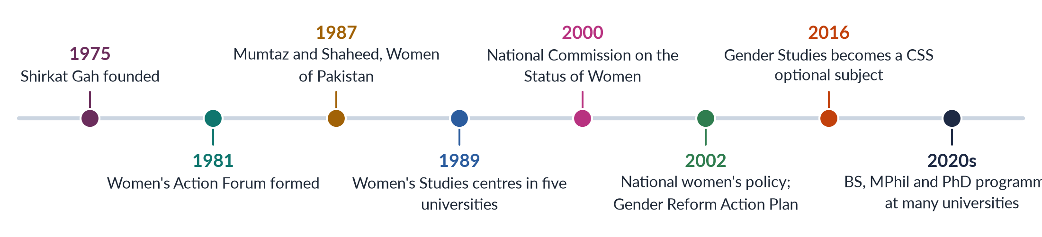
Figure 10 · Milestones of Gender Studies in Pakistan.

5.3 Growth and achievements
1. Degrees. Gender Studies is now taught at BS, MPhil and PhD level at many public universities and some private ones. It is also a course inside sociology, social work and development programmes.
2. Local research. Research on violence against women, honour crimes, family law, political participation, women's work, health and education. Commissions, courts and NGOs use much of it.
3. Journals. Journals such as the Pakistan Journal of Gender Studies (asked in a 2018 MCQ) and Pakistan Journal of Women's Studies: Alam-e-Niswan publish local research.
4. Trained people. Graduates work in the National Commission on the Status of Women (2000), the provincial women's commissions, women's protection centres, development programmes and NGOs.
5. Influence on policy. Researchers helped shape the National Policy for Development and Empowerment of Women (2002), the Gender Reform Action Plan of the early 2000s, the debate on the 2002 quota for women in parliament and the pro-women laws of 2006–2025.
6. Recognition. Gender Studies became a CSS optional subject from CE-2016 — itself a sign that the field has arrived.

5.4 The problems
Two reviews of the field are on the FPSC reading list — by Rubina Saigol and by Farzana Bari. Read together with later reviews and the experience of the centres, they point to a set of problems that keep returning:
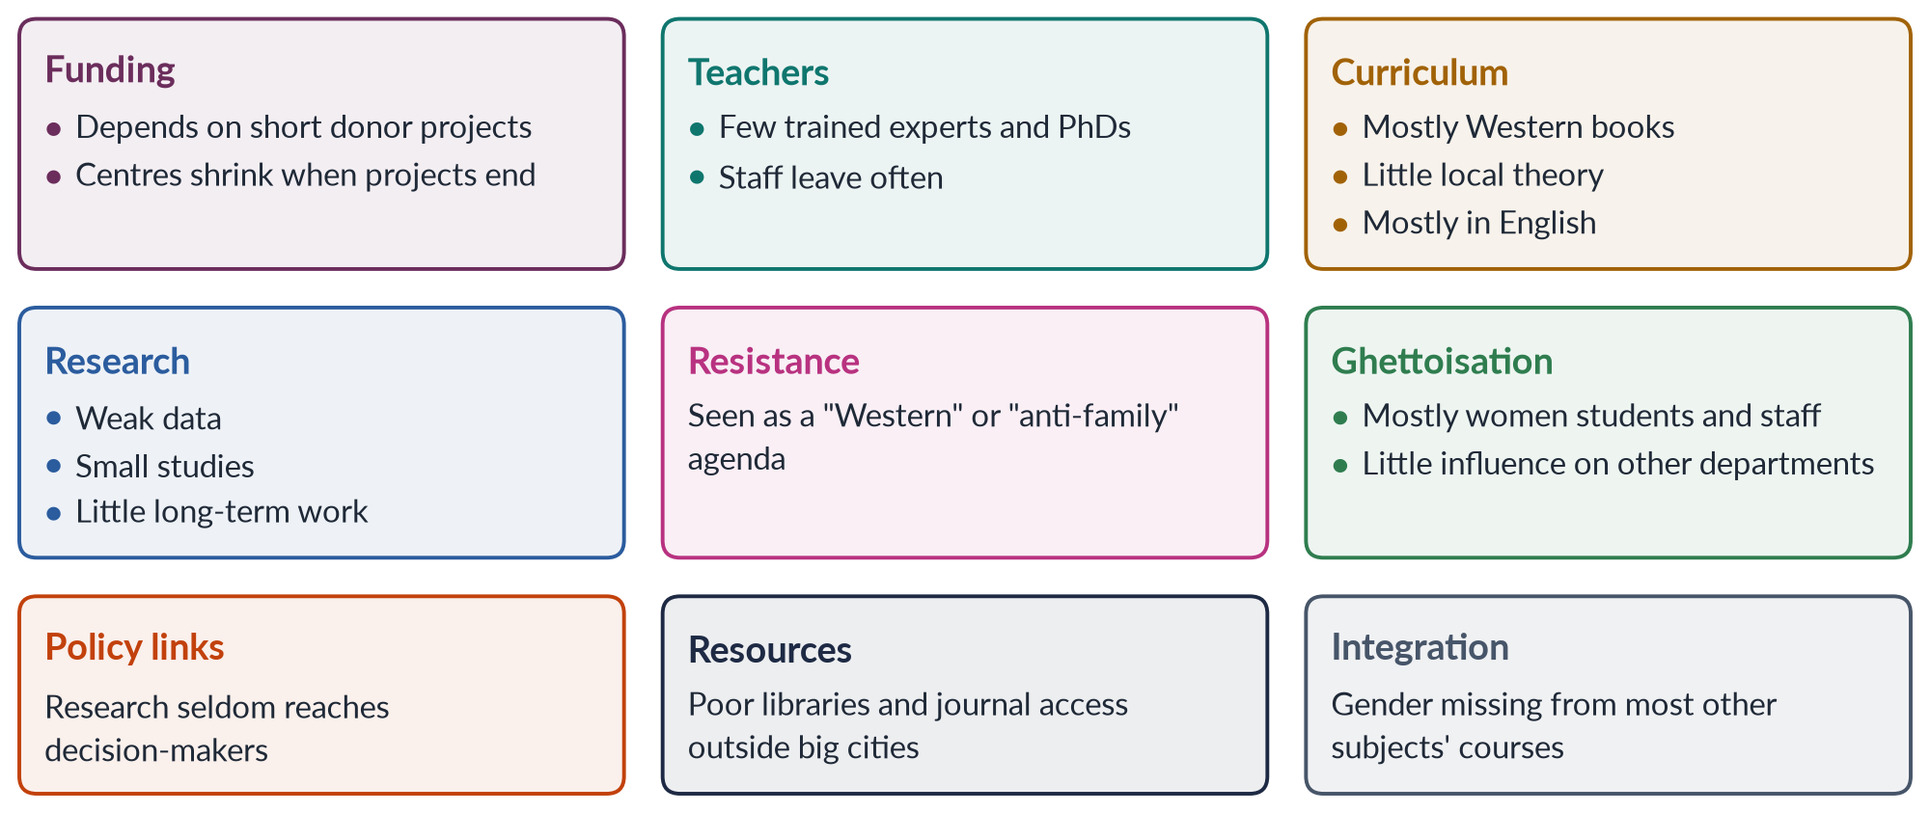
Figure 11 · The problems that keep returning.
REMEMBER · THREE KINDS OF PROBLEM
The field's problems are financial (short donor projects), intellectual (borrowed theory, little local research) and political (social resistance and the charge of a "Western agenda"). A strong answer names all three, gives one example of each, and gives a remedy for each.

HOT DEBATE · "A WESTERN AGENDA"?
Critics say Gender Studies brings in Western values that clash with Pakistani culture and religion. Defenders give three replies. (1) Women's activism in South Asia has deep local roots — from nineteenth-century reformers to the women of the Pakistan Movement. (2) The problems the field studies — deaths in childbirth, illiteracy, violence, poverty — are Pakistani problems, measured with Pakistani data. (3) Muslim scholars themselves have built a rich tradition of writing on gender. The best answer to the charge is more local research, local theory and local languages.

5.5 An honest assessment
How far has the field succeeded in Pakistan? A fair verdict weighs what has been built against what is missing.
Table 5 · Gender Studies in Pakistan: a balance sheet.
What has been achieved | What is still missing
A recognised field with degrees up to PhD | Steady public funding that does not depend on donors
A generation of trained people in government, commissions and NGOs | Enough expert teachers outside the big cities
Research that helped the pro-women laws of 2006–2025 | Long-term, large studies of Pakistani families and regions
Public words for once-hidden problems (harassment, domestic violence, care work) | Theory rooted in Pakistan's own history, languages and religious traditions
Recognition as a CSS optional subject | Gender inside medicine, law, economics, engineering and teacher training

EXAMPLE · THE FIELD AT WORK
When Parliament and the provincial assemblies debated the laws on harassment at work (2010), acid attacks (2011), honour killing (2016) and violence at home (Punjab 2016; Islamabad 2025), they used evidence gathered by researchers, commissions and NGOs — much of it by people trained in Women's and Gender Studies. The field's influence is often hidden, but it is real.
➜ The strongest argument for the discipline in Pakistan is its record of turning research into law and policy.

5.6 The way forward
1. Steady funding through the Higher Education Commission instead of short donor projects.
2. Training teachers — PhD scholarships in Gender Studies and training for teachers of other subjects.
3. Local knowledge — research on Pakistani families, regions, religions and languages; books in Urdu and regional languages; dialogue with Islamic scholarship.
4. Integration — gender modules in medicine, law, economics, education and civil-service training (the dual strategy of Chapter 4).
5. Links with policy — partnerships with the NCSW, provincial commissions, the Bureau of Statistics (for gender data) and parliament's Women's Caucus.
6. Involving men — as students, teachers and subjects of research (masculinity studies).
7. Research on overlapping disadvantage — on minority, rural, disabled and poor women, whose lives the field still knows too little about.
EXAMINER'S EYE · THE "STATUS" ANSWER IN FIVE HEADINGS
1. History (NGOs; the 1989 centres); 2. Institutions and programmes today; 3. Achievements (research, trained people, policy, CSS); 4. Problems (funding, teachers, curriculum, resistance, ghettoisation); 5. The way forward. When the question adds "give your views on autonomy versus integration" (2016, 2023), make heading 6 the debate and argue for the dual strategy in Pakistan.

Chapter 6 · Historicizing Constructionism — and the Theories of Social Construction
"Historicizing constructionism" means telling the history of one idea: that gender is made by society, not given by nature. This chapter follows that idea from its opponents, to its founders, to its boldest forms. Then it sets out the theories of how gender is made — the subject of the 2016 question.

6.1 Two opposite views: essentialism and constructionism
✦ DEFINITION
Essentialism · the older view
The belief that women and men have a fixed, natural "essence" — built into their bodies, brains or souls — which explains why they behave differently and hold different roles.
➜ If essentialism is true, gender inequality is natural and cannot (or should not) be changed.

✦ DEFINITION
Social constructionism · the idea at the heart of Gender Studies
The view that gender — and, for some thinkers, even sex and sexuality — is made by society: by upbringing, language, institutions, law, religion and everyday life.
➜ If constructionism is true, gender arrangements have a history, differ between societies, and can be changed.

To "historicize" constructionism is to show that this idea itself has a history: when it appeared, who developed it, how it grew bolder, and what its critics said.

6.2 Before constructionism: the long rule of essentialism
For most of history, women's lower position was explained by "nature".
- The Greek philosopher Aristotle (4th century BCE) described the female as a kind of incomplete male, and said men were naturally fit to rule.
- Nineteenth-century European science claimed that women's smaller brains, their wombs or their "nervous" nature made them unfit for higher education or politics. Some doctors warned that study would harm girls' ability to have children.
- Social Darwinism presented the existing roles of men and women as the natural product of evolution.
IN SIMPLE WORDS
Essentialism says: "Women are like this because they are women." Constructionism asks: "Who taught women to be like this — and why?"

6.3 The first challenges (1792–1869)
✦ THINKER
Mary Wollstonecraft · *A Vindication of the Rights of Woman* (1792)
Wollstonecraft argued that women seemed weak and silly not by nature, but because they were denied education and trained only to please men.
➜ The first clear claim that "feminine" character comes from upbringing.

✦ THINKER
John Stuart Mill · *The Subjection of Women* (1869)
"What is now called the nature of women is an eminently artificial thing — the result of forced repression in some directions, unnatural stimulation in others."
➜ In simple words: what we call women's "nature" is made by how women are treated — held back in some ways, pushed in others.

6.4 Anthropology and philosophy (1935–1949)
- Margaret Mead (Sex and Temperament in Three Primitive Societies, 1935) studied three peoples in New Guinea. Among the Arapesh, both men and women were gentle and caring. Among the Mundugumor, both were fierce. Among the Tchambuli, women were in charge and practical, while men were decorative and emotional. If "masculine" and "feminine" qualities can be shared or reversed, they cannot be fixed by sex.
- Simone de Beauvoir (The Second Sex, 1949) wrote the most famous sentence in the subject: "One is not born, but rather becomes, a woman." She argued that society treats man as the normal human and woman as "the Other" — the second sex — and that upbringing, marriage, religion and law turn girls into this "Other".

6.5 The sex/gender distinction (1955–1972)
- The psychologist John Money first used the term "gender role" in 1955 for the behaviour through which a person shows they are a boy or a girl.
- The psychiatrist Robert Stoller (Sex and Gender, 1968) separated biological sex from gender identity — a person's inner sense of self.
- The British sociologist Ann Oakley (Sex, Gender and Society, 1972) brought the distinction into the social sciences: sex is biological; gender is cultural, and it differs from one society to another.

6.6 How "made" things come to feel natural (1966–1978)
✦ THINKER
Peter Berger and Thomas Luckmann · *The Social Construction of Reality* (1966)
People create social arrangements (they "externalise" them). Over time these arrangements start to look like solid facts ("objectivation"). Each new generation then learns them as if they were natural ("internalisation").
➜ This three-step process explains how a human-made arrangement such as gender roles comes to feel like "nature".

- Harold Garfinkel (1967) studied "Agnes", a person who lived as a woman, and showed that being seen as a woman is something one must keep achieving in daily life.
- Suzanne Kessler and Wendy McKenna (1978) showed that we decide a stranger's gender from clues such as clothes and voice, not from their chromosomes.

6.7 The bold forms of constructionism (1975–1994)
- Gayle Rubin (1975) described the "sex/gender system" — the arrangements by which a society turns biological sex into social roles.
- Michel Foucault (The History of Sexuality, vol. 1, 1976) argued that modern ideas of "sexuality" were produced by medicine, psychiatry and law — power created talk about sex rather than only silencing it.
- Candace West and Don Zimmerman ("Doing Gender", 1987) argued that gender is not something we have but something we do, again and again, in daily interaction.
- Judith Butler (Gender Trouble, 1990) argued that gender is performative: repeated acts create the appearance of a natural gender inside us. She added that even "sex" is seen through the lens of gender (Chapter 8).
- Judith Lorber (Paradoxes of Gender, 1994; the chapter "The Social Construction of Gender" is on the FPSC reading list) described gender as a social institution — like the economy or religion — that organises all of social life.
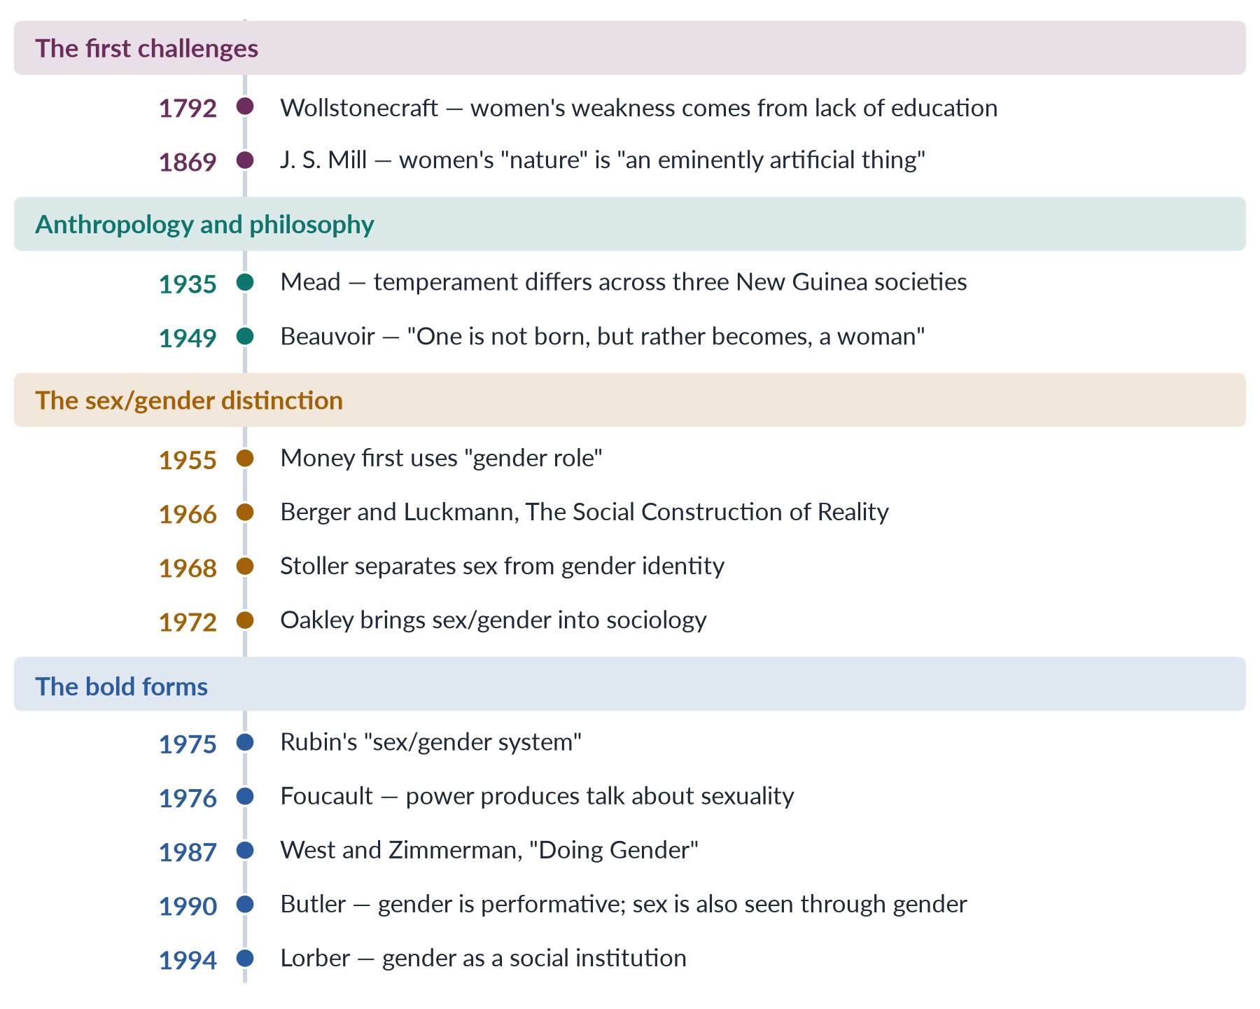
Figure 12 · Historicizing constructionism: how the idea that gender is made grew over two centuries.

6.8 The theories of social construction of gender
The 2016 question asked: "What are the theories of social construction of gender?" There are seven main theories. Each answers the same question — how does a baby become a gendered adult? — from a different angle.
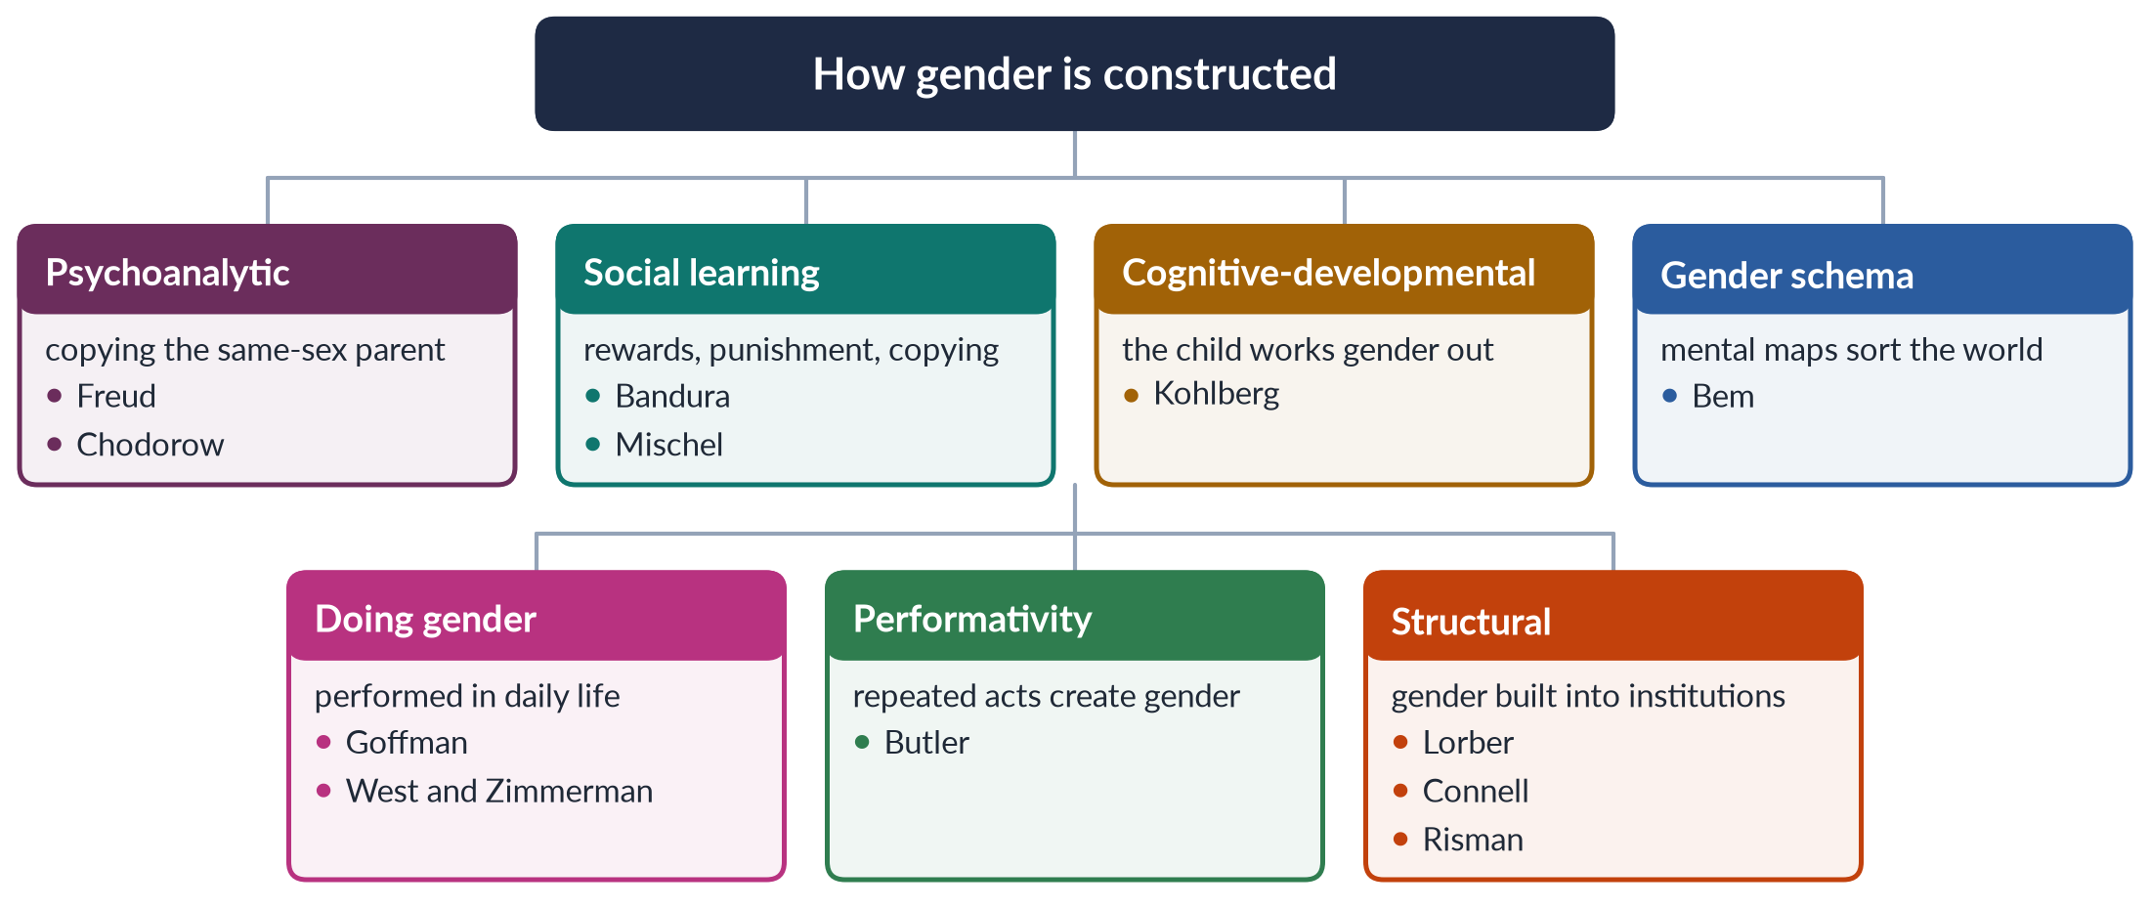
Figure 13 · The theories of the social construction of gender.

(1) Psychoanalytic theory
Freud argued that children form their gender identity by identifying with the parent of the same sex, after early family conflicts. Nancy Chodorow (The Reproduction of Mothering, 1978) changed this into a social theory. Because women do almost all early childcare, girls grow up identifying with their mothers and learn to care for others. Boys learn to be "men" by separating from their mothers and hiding feelings. So each generation of mothering reproduces gender. (Topic 2 covers psychoanalytic feminism in full.)

(2) Social learning theory
Children learn gender like anything else: through reward and punishment (praise for "right" behaviour, scolding for the "wrong" kind) and by copying models — parents, older brothers and sisters, teachers, film heroes. The psychologists Albert Bandura and Walter Mischel (1966) developed this view. Example: a Pakistani boy praised for being "brave like a man" and a girl praised for being "shy and sensible" are being taught their gender.

(3) Cognitive-developmental theory
Lawrence Kohlberg (1966) argued that children actively work out gender, in three stages:
1. Gender identity (about age 2–3): "I am a girl."
2. Gender stability (about age 4–5): "I will grow up to be a woman."
3. Gender constancy (about age 6–7): "I stay a girl even if I cut my hair."
Once children know their gender, they look for behaviour that fits it — they teach themselves.

(4) Gender schema theory
Sandra Bem (1981) joined the last two theories. Children build a gender schema — a mental map that sorts toys, colours, jobs and feelings into "for boys" and "for girls". They then filter everything through it: they remember what fits and ignore what does not. Societies that stress gender all the time create strong schemas.

(5) "Doing gender" (interactionist theory)
Erving Goffman (Gender Advertisements, 1979) showed how gender is displayed in posture, dress and poses. West and Zimmerman (1987) argued that people "do gender" in every interaction and are judged if they do it "wrong". Example: the way men and women are expected to sit, speak, greet elders or eat in public in Pakistan.

(6) Performativity
Butler (1990) went further. There is no gender "inside" us that our actions express. The repeated actions themselves create what we experience as our gender. Because gender depends on repetition, it can change if people repeat differently.

(7) Structural theories
Gender is also built into society's structures, not only into individuals. Lorber (1994) calls gender an institution. Raewyn Connell describes a "gender order" of power, work and feeling. Barbara Risman (2004) calls gender a social structure that works at three levels: the individual, everyday interaction and institutions. Example: inheritance customs, dowry, school timetables and the lack of women's toilets in offices shape gender whatever individuals believe.
PAKISTAN ANGLE · THE AGENTS THAT CONSTRUCT GENDER IN PAKISTAN
• Family: boys may roam outside; girls stay close to home; sons' education comes first; daughters learn housework early.
• School: textbooks show mothers cooking and fathers in offices; boys and girls are expected to behave differently.
• Religion and community: sermons and elders' advice on the "proper" roles of men and women.
• Media: television dramas reward the self-sacrificing wife; adverts sell cleaning products to women and cars to men.
• The state and law: laws on guardianship, inheritance and family that assume a male head of the house.

6.9 The critique of constructionism
1. It can ignore the body. Some differences are real — in childbirth and, on average, in physical strength (Chapter 10).
2. It can make people look passive. Early theories imagined children simply soaking up roles. In reality people resist, bargain and rewrite them.
3. Relativism. If everything is "made", on what basis can we call some arrangements unjust? (Feminists reply: on the basis of harm and equal human dignity.)
4. Universals. If gender is only local, why is male dominance found in so many societies?
5. Too abstract. The philosopher Martha Nussbaum ("The Professor of Parody", 1999) criticised Butler's writing as unclear and far from the practical struggles of real women.
EXAMINER'S EYE · THE MODEL STRUCTURE FOR "WHAT ARE THE THEORIES OF SOCIAL CONSTRUCTION OF GENDER?"
1. Introduction: define social construction; Beauvoir's sentence; sex vs gender. 2. Background: essentialism and its decline. 3–9. The seven theories, each with its thinker, how it works and a Pakistani example. 10. The agents of socialisation. 11. Critique. 12. Conclusion: biology gives the raw material, society builds the roles, and people can rebuild them. Draw the tree of theories.

Chapter 7 · Deconstructing "Gender" — and Gendered Language
In 2020 the examiner asked two unusual questions: "Gender has multiple meanings. How do you deconstruct the word 'GENDER'?" and "'Language is gendered.' What does this imply?" Both are about words — what one word means, and what all our words do. This chapter answers both.

7.1 What "deconstruction" means
✦ THINKER
Jacques Derrida · French philosopher · *Of Grammatology* (1967)
Derrida argued that Western thinking is built on pairs of opposites — reason/emotion, culture/nature, mind/body, public/private. In each pair the first word is treated as better and the second as lower. To deconstruct an idea is to take it apart, show these hidden rankings, and show that the opposition is not natural.
➜ To deconstruct "gender" is to show the many meanings packed into the word and the ranking hidden in the pair masculine/feminine.

Feminists noticed something about Derrida's pairs. In each one, the "better" side is linked with men (reason, culture, mind, public life) and the "lower" side with women (emotion, nature, body, home). So deconstruction became a feminist tool.

7.2 The many meanings of "gender"
The word comes from the Latin genus ("kind" or "type"), through Old French gendre. For centuries it meant only a category of grammar. Its meanings have since multiplied.
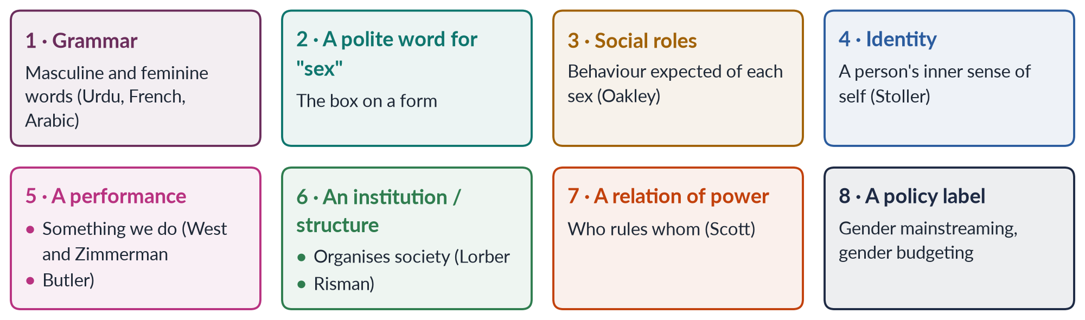
Figure 14 · Deconstructing "gender": eight meanings layered in one word.

(1) Gender as grammar
In many languages every noun has a gender. In Urdu, kitaab (book) is feminine and qalam (pen) is masculine, and verbs change with the gender of the speaker. This is the oldest meaning. It shows that dividing the world into two genders is built into language itself (§7.4).

(2) Gender as a polite word for sex
In daily speech and on forms, "gender" often just means "male or female". This is the loosest meaning. It is the one Gender Studies tries to correct, because it treats social roles as if they were as fixed as the body.

(3) Gender as social roles
For Ann Oakley and the sociologists of the 1970s, gender means the roles, behaviour and expectations a society attaches to each sex: man as earner, woman as homemaker. In this sense gender differs between societies and changes over time.

(4) Gender as identity
For psychologists since Robert Stoller (1968), gender also means a person's inner sense of self — being a woman, a man, both or neither. This meaning is at the centre of today's debates on transgender rights (Chapter 11).

(5) Gender as a performance
For West and Zimmerman (1987) and Butler (1990), gender is not something we are but something we do, through repeated acts that make it look natural. Here gender is a verb, not a noun.

(6) Gender as an institution or structure
For Judith Lorber (1994) and Barbara Risman (2004), gender is an institution that organises the whole of society — work, family, law, religion — and places people in unequal positions.

(7) Gender as a relation of power
✦ QUOTATION
Joan Wallach Scott · "Gender: A Useful Category of Historical Analysis" (1986)
"Gender is a constitutive element of social relationships based on perceived differences between the sexes, and gender is a primary way of signifying relationships of power."
➜ In simple words: gender is a main way of showing and justifying power — not only between men and women, but in politics, war and the economy.

(8) Gender as a policy label
Since the 1990s "gender" has also become a technical word of governments and donors — gender mainstreaming, gender budgeting, gender focal persons. Critics warn that in this sense the word can lose its political meaning, becoming a box to tick rather than a power relation to change.

7.3 Deconstructing the pair masculine/feminine
Table 6 · The pair hidden inside "gender" — and the ranking it hides.
"Masculine" (valued more) | "Feminine" (valued less)
Reason, logic | Emotion, feeling
Strength, action | Weakness, passivity
Culture, civilisation | Nature, the body
Public life: politics, markets | Private life: home, family
Independence | Dependence, care
Leadership | Obedience

Deconstruction makes three points about this table:
1. The pairs are ranked. The left side is valued more — and paid more.
2. The pairs are not natural. Every person has something of both columns. Sandra Bem called this androgyny (Chapter 9).
3. The pairs are unstable. The lists change with time and place. In some South Asian traditions, care and feeling were honoured in male saints. In today's Pakistan, women excel in "logical" fields such as medicine and engineering.
IN SIMPLE WORDS
To deconstruct "gender" is to open a suitcase labelled "natural" and find it full of history, language, power and politics.

7.4 "Language is gendered" — what it implies
To say language is gendered means three things:
1. Language reflects a society's gender ranking.
2. Language passes that ranking on, teaching each new generation to see the world through it.
3. Language can therefore be changed, as part of changing the ranking.
✦ THINKER
Dale Spender · Australian feminist scholar · *Man Made Language* (1980)
Spender argued that men, as the more powerful group, have mostly controlled what words mean. So language itself carries a male view of the world, and women's experiences are harder to name.
➜ Before the terms "sexual harassment" and "domestic violence" existed, women found it hard even to describe these experiences — let alone challenge them.

The forms of gendered language
Table 7 · How language carries gender bias — with English and Urdu examples.
Form | What it is | Examples
Male words for everyone | Male words used for all people (the "generic masculine") | "mankind", "man-made", "chairman", "every student must bring his book"; in Urdu, a mixed group is addressed in the masculine
Marked female words | Women treated as the exception | "lady doctor", "woman pilot", "actress", "female engineer"
Words that lose respect | Female words gain negative meanings over time (Muriel Schulz, 1975) | master / mistress; bachelor / spinster; sir / madam
Insults and sayings | Womanhood used as an insult; women stereotyped | "choorian pehen lo" (put on bangles — i.e., coward); "aurat ki aql" (a woman's wit, meaning foolishness); "zan, zar, zameen" (women, gold and land as the causes of fights)
Names and titles | Women named through men | "Mrs + husband's name"; a wife called "ghar wali" or "bachon ki ammi"; a woman's name kept private in public
Excusing violence | Violence described so as to excuse it | "she provoked him"; "honour" killing (which makes murder sound like a defence of honour); "eve-teasing" for harassment
Patterns of talk | Differences in how women and men are heard | Lakoff's "women's language" of hedges and tag questions (1975); men interrupting women (Zimmerman and West, 1975); "rapport talk" vs "report talk" (Tannen, 1990)

✦ THINKER
Robin Lakoff · American linguist · *Language and Woman's Place* (1975)
Lakoff argued that girls are taught a "women's language" of hedges ("sort of"), tag questions ("isn't it?"), extra politeness and empty words. This makes women sound unsure and stops them being taken seriously.
➜ Ways of speaking are learnt, and they carry real costs in classrooms, offices and parliaments.

What gendered language does
1. It makes women invisible. Studies find that people picture men when they hear words like "chairman".
2. It fixes stereotypes. Sayings and proverbs present women as weak, foolish or dangerous.
3. It lowers value. Words for women's roles lose respect over time.
4. It makes violence seem normal. Words that blame victims or dignify killing ("honour") make violence look acceptable.
5. It silences. If there is no word for an experience, women cannot name it, report it or seek justice.

Changing the language
- Inclusive words: "chairperson", "police officer", "humankind", "they" for an unknown person. The United Nations has issued guidelines on gender-inclusive language.
- New words for old harms: "sexual harassment", "domestic violence", "femicide", "glass ceiling".
- Respectful words in local languages: khawaja sira in place of insulting terms; the name "Aurat March", which turns aurat into a word of pride.
PAKISTAN ANGLE · GENDERED LANGUAGE IN PAKISTANI LAW
Pakistan's laws have slowly changed their words. The Protection against Harassment of Women at the Workplace Act 2010 named harassment as a legal wrong. The 2016 law speaks of crimes committed "in the name or pretext of honour" — calling "honour" a pretext (an excuse), not a justification. The Transgender Persons Act 2018 gave legal terms for gender-diverse people. Changing the words was part of changing the law.

TRAP · TWO TRAPS IN "LANGUAGE IS GENDERED"
• Do not write only about grammar (masculine and feminine nouns). The examiner wants the social meaning: how language reflects and passes on power.
• Do not claim that changing words alone ends inequality. Language reform works together with change in law, work and attitudes.

Chapter 8 · Problematizing "Sex": Queer Theory — and Is Sex Made by Society Too?
Two syllabus lines — "Problematizing the category of 'Sex': Queer Theory" and "Is 'Sex' socially determined, too?" — are taught together here. The examiner asked the second as a short note in 2024, and joined both to Pakistani law in 2026. You need to explain queer theory clearly, give both sides of the question about sex, and reach a careful conclusion.

8.1 What it means to "problematize" sex
For the first scholars of gender, sex was the solid biological ground and gender the social building on top of it. To problematize sex means to ask whether that ground is really so solid and simple. Are there exactly two sexes? Who decides? What happens to bodies that do not fit? Does the meaning we give to bodies come from nature or from culture?
IN SIMPLE WORDS
The first question of Gender Studies was: "Is gender made by society?" Queer theory asks a second, harder question: "Is even our idea of sex made by society?"

8.2 Queer theory

(1) Where it came from
Queer theory appeared around 1990 from two sources:
- Activism. In the late 1980s, AIDS activists and groups such as Queer Nation (1990) took back the word "queer" — once an insult — as a word of pride.
- Scholarship. The theorist Teresa de Lauretis first used the term "queer theory" for a conference in 1990 (published 1991). The same years produced its founding books: Judith Butler's Gender Trouble (1990) and Eve Kosofsky Sedgwick's Epistemology of the Closet (1990). Both built on Michel Foucault's History of Sexuality (1976).
TRAP · WHAT QUEER THEORY IS NOT
Queer theory is not simply "a new term for gays and lesbians" — this was the wrong statement in a 2023 MCQ. It is a theory that questions all fixed boxes of sex, gender and sexuality, including the "normal" ones.

(2) Its main claims
1. Categories have a history. Sexual and gender identities are not timeless; they were produced in particular times by particular ways of talking. Foucault argued that "the homosexual" as a type of person was a nineteenth-century medical idea.
2. Heteronormativity. Society assumes there are two opposite genders and that only heterosexuality is normal, and builds law, family and culture on that assumption.
3. Identities are fluid and performed. Following Butler, identities are produced by repetition, not by a fixed inner essence.
4. Pairs of opposites should be taken apart — male/female, masculine/feminine, straight/gay.
5. Study the edges to see the centre. By studying people who do not fit the norm, we see how the norm is made and enforced.
✦ THINKER
Judith Butler · American philosopher · *Gender Trouble* (1990)
"If the immutable character of sex is contested, perhaps this construct called 'sex' is as culturally constructed as gender; indeed, perhaps it was always already gender, with the consequence that the distinction between sex and gender turns out to be no distinction at all."
➜ In simple words: Butler does not say bodies are unreal. She says we can only see and sort bodies through the gender categories our culture gives us.

8.3 Is sex made by society too? — the case for "yes"

(1) History: the "one-sex" model
✦ THINKER
Thomas Laqueur · American historian · *Making Sex* (1990)
Laqueur argued that for centuries European medicine used a "one-sex" model: it saw the female body as an inside-out, less perfect version of the male body. Only in the eighteenth century did a "two-sex" model of opposite bodies take over — for social and political reasons as much as scientific ones.
➜ What counts as "sexual difference" has itself changed over history.

(2) Biology: bodies vary
Chromosomes, hormones, internal organs and outward anatomy do not always line up in the usual male or female pattern. People born this way are called intersex. The biologist Anne Fausto-Sterling ("The Five Sexes", 1993; Sexing the Body, 2000) argued that sex is better seen as a range than as two boxes.
✦ DATA
How common is intersex? · estimates differ with the definition
Fausto-Sterling's broad definition gave an estimate of about 1.7% of births. The psychologist Leonard Sax (2002), counting only cases where chromosomes and anatomy clearly conflict, estimated about 0.018%.
➜ The number depends on how "intersex" is defined — and the definition is itself a human decision. Always give the range, never one number.

(3) Medicine: doctors decide
For decades doctors assigned intersex babies to one sex, often by surgery. They used social tests — for example, whether the child would "look normal" — rather than purely biological ones. The sorting of bodies was a human decision.

(4) Sport and law: the rules keep changing
International sports bodies have repeatedly changed the tests that decide who may compete as a woman — from physical checks, to chromosome tests, to hormone levels. Each change has been disputed, for example in the case of the South African runner Caster Semenya. If sex were simple, it would not need so many shifting rules.

8.4 The case for "no" — sex is biological
1. Reproduction has two sides. Human reproduction needs two kinds of reproductive cells (eggs and sperm). This is the biological basis of the two sexes.
2. Most people fit clearly. The great majority of people are plainly male or female. Variation at the edges does not erase the categories.
3. Sorting is not creating. Societies sort bodies and give them meaning, but they do not create chromosomes or hormones. Mixing the two is confusing the map with the land.
4. Real consequences. Biological sex matters for medicine (pregnancy, childbirth, many diseases) and for protections such as women's sport and women-only spaces — a point stressed by some feminists who reject the idea that sex is constructed.
5. Too abstract. Critics such as Martha Nussbaum (1999) argue that queer theory's abstract style draws attention away from the practical struggles of women in poor countries.

8.5 The middle position
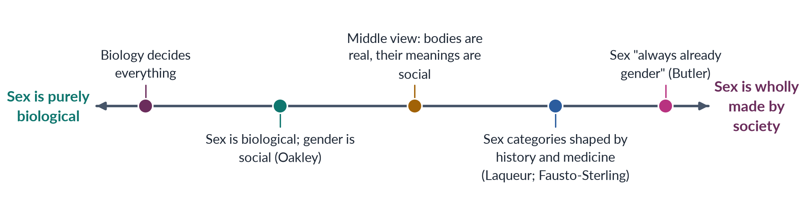
Figure 15 · Positions on the question "Is sex made by society?"
Most scholars now take a middle (interactionist) position. Bodies and their variation are real. But the decisions — how many categories there are, where to draw the lines, which differences count, and what they mean for a person's rights and role — are made by societies and change over time. In this sense, sex is a biological fact seen through social categories.
ISLAMIC PERSPECTIVE · BODILY VARIATION IN THE ISLAMIC LEGAL TRADITION
Classical Islamic law recognised the khuntha — a person with features of both sexes — and set out detailed rules for such persons on inheritance, prayer and marriage, usually deciding their legal status by physical signs. South Asian societies also long recognised gender-variant communities (hijras or khawaja siras), who held established roles at the Mughal court. These traditions show that recognising human variation is not a modern Western idea — while they also kept a basically two-sex legal framework.
➜ A balanced answer can use this tradition to show both the recognition of variation and its limits — the background to Pakistan's current legal debate (Chapter 11).

8.6 Evaluating queer theory
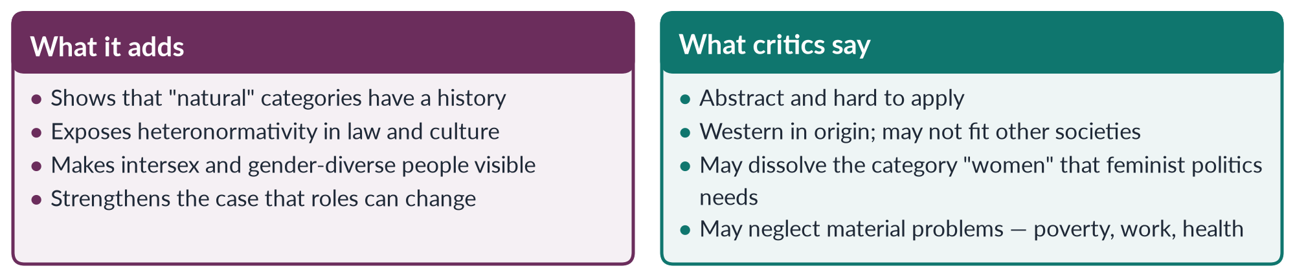
Figure 16 · What queer theory adds, and what its critics say.
EXAMINER'S EYE · THE SHORT NOTE (2024): "IS 'SEX' ALSO A SOCIAL CONSTRUCT?"
In 550–650 words: (1) define sex and gender and the original distinction (Oakley, 1972); (2) the case for "yes" — Laqueur, intersex variation (with the range of estimates), doctors' decisions, Butler's sentence; (3) the case for "no" — reproduction, most people fit, sorting is not creating; (4) conclusion — bodies are real, but how we sort them and what they mean is social. One example (sports sex tests, or the khuntha in Islamic law) lifts the note above the average.

Chapter 9 · Masculinities and Femininities
The syllabus line is "Masculinities and Femininity". The examiner asked in 2021 whether masculinity and femininity are natural or social, in 2023 to define them and explain where traditional gender roles come from, and in 2026 about masculinity studies and violence. This chapter gives you the definitions, the key theory (Connell), where roles come from, and the costs of the dominant model.

9.1 Definitions
✦ DEFINITION
Masculinity · what society expects of men
The behaviour, qualities, roles and ideals that a society links with being a man — for example strength, courage, hiding emotion, providing for the family and authority over dependants.
➜ Masculinity is plural: there are many masculinities, and they are ranked.

✦ DEFINITION
Femininity · what society expects of women
The behaviour, qualities, roles and ideals that a society links with being a woman — for example modesty, gentleness, care, beauty, obedience and sacrifice for the family.
➜ Femininity is also plural. It is usually defined in relation to — and in the service of — the dominant masculinity.

Three features follow from these definitions:
1. They are relational. Each is defined against the other. To be "a real man" means, above all, not to be "like a woman".
2. They are plural. A rural Sindhi landlord, a Karachi software engineer and a young Pashtun labourer each live a different masculinity.
3. They are ranked and changeable. Some forms are honoured, others looked down on — and the ranking changes over time.

9.2 Connell's theory of masculinities
✦ THINKER
Raewyn Connell · Australian sociologist · *Gender and Power* (1987); *Masculinities* (1995)
Connell argued that every society has a "gender order" — a pattern of power between different masculinities and femininities. At the top stands hegemonic masculinity: the most honoured way of being a man, which justifies men's power over women and over other men. Few men fully live up to it, but most men gain from it.
➜ The examiner asked "who coined hegemonic masculinity?" in 2018, 2023 and 2026. The answer is R. W. (Raewyn) Connell.

"Hegemony" is a word Connell borrowed from the Italian thinker Antonio Gramsci. It means power that rules mainly through consent and admired ideals, not only through force. Hegemonic masculinity rules because people come to see it as normal and admirable.
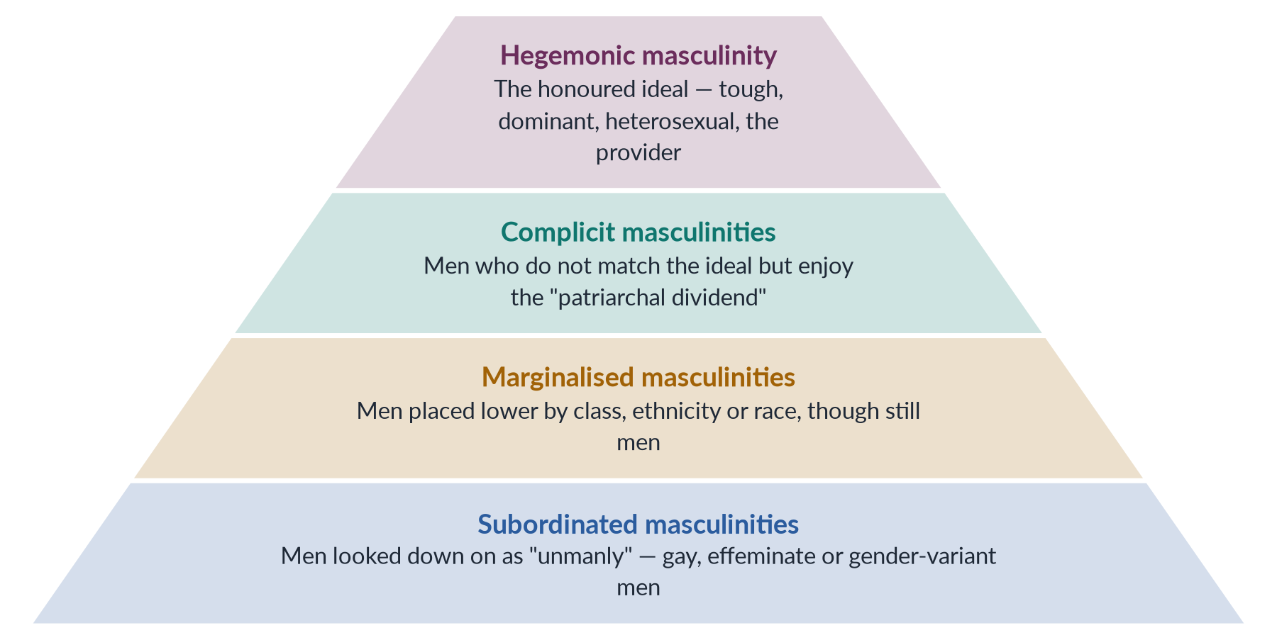
Figure 17 · Connell's ranking of masculinities.
- Hegemonic masculinity — the honoured ideal.
- Complicit masculinities — most men. They do not fully match the ideal, but they support it and gain from it. Connell calls this gain the patriarchal dividend: the advantage men as a group get from women's lower position.
- Marginalised masculinities — men placed lower because of class, ethnicity or race, such as poor labourers or minority men.
- Subordinated masculinities — men looked down on as not "real men", above all gay and effeminate men, and in South Asia many khawaja siras.
- Emphasised femininity — Connell's name for the kind of femininity built around pleasing and serving men. It is honoured, but never on top, because all femininities are placed below masculinity.
EXAMPLE · MASCULINITIES IN PAKISTAN
In many communities the honoured ideal is the *ghairat-mand* (honour-bound) man who protects and controls "his" women, provides for the family, never shows weakness and defends his name. A young man who cannot find work, or a man who helps with cooking and childcare, may be mocked as *joru ka ghulam* ("his wife's slave"). Such mockery shows how the ranking is enforced.

9.3 Femininities
Femininities are also taught and enforced:
- The "good woman" ideal: modest, obedient, patient, self-sacrificing, guarding the family's *izzat* (honour). The *sharif aurat* (respectable woman) is praised. A woman who speaks loudly, works late or chooses her own husband may be condemned.
- Beauty rules: fair skin, slimness and youth — sold through adverts for skin-whitening creams.
- The double burden: the modern ideal expects women to earn money and do all the housework.
- Women who push back: activists, athletes, pilots, mountaineers and young women on social media show that femininity, too, can change.

9.4 Natural or social? The theoretical debates
The 2021 question asked you to "discuss various theoretical debates on their construction to make explicit whether the formation of both is a natural or social reality".
Table 8 · The theoretical debates on masculinity and femininity.
Theory | What it says | Natural or social?
Biological / evolutionary | Hormones (testosterone), brain differences and evolution produce male aggression and female caring | Mainly natural
Psychoanalytic (Freud; Chodorow) | Identities form through early family relationships | Social, through the family — but deep and hard to change
Social learning (Bandura) | Children learn roles by reward, punishment and copying | Social
Cognitive (Kohlberg; Bem) | Children build mental maps of gender | Social, through the child's own thinking
Sociological (Connell) | Masculinities are produced in a gender order of power, work and feeling | Social and political
Performative (Butler) | Gender is created by repeated acts | Social — and can change
Interactionist (the modern view) | Biology gives tendencies; society shapes, strengthens or reverses them | Both — but the form and ranking are social

The evidence for the social side is strong. Masculinities and femininities differ between cultures (Mead's three societies, Chapter 6), change over time (women working in factories during the World Wars; the rise of the caring father), and differ within a society (by class, region and religion). Biology explains some average differences, but not the huge variety of forms, and not why one form is honoured and another despised. Chapter 10 looks at this debate in full.

9.5 Where do traditional gender roles come from?
The 2023 question asked for your opinion on where traditional roles come from. A complete answer gives several causes, each with evidence.
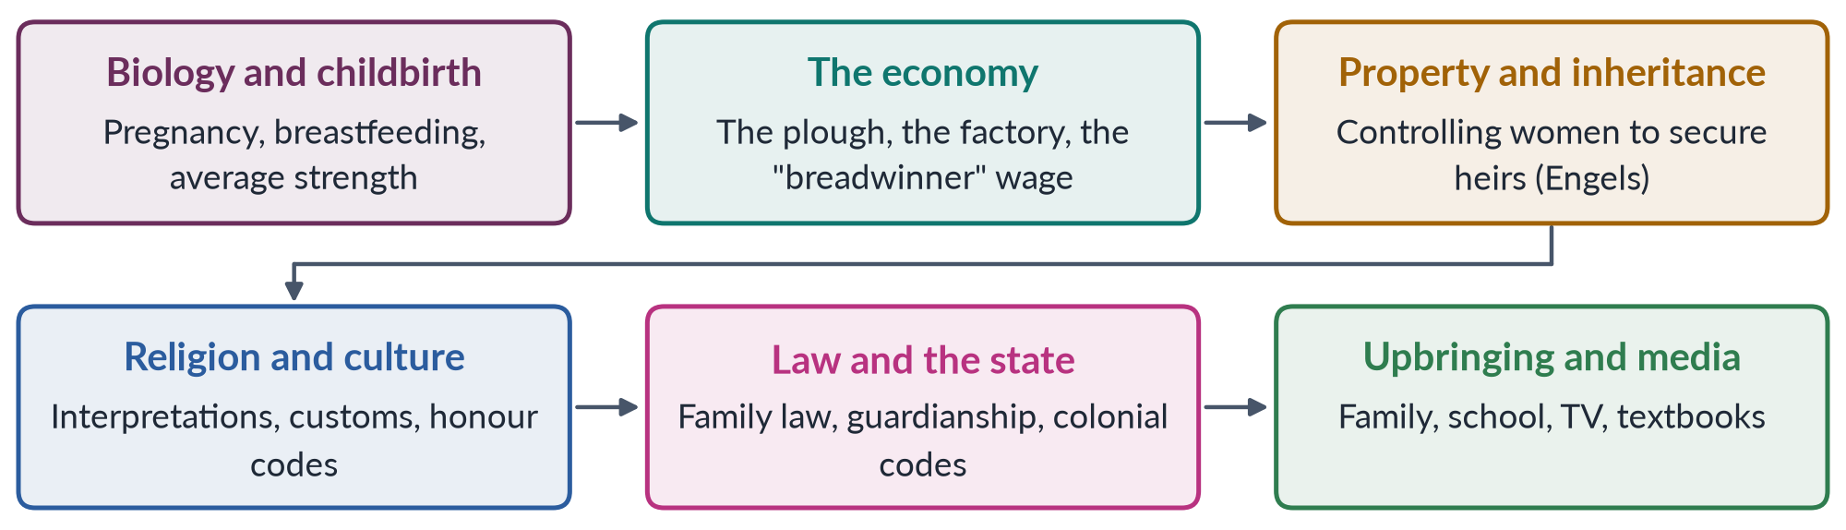
Figure 18 · Where traditional gender roles come from: six sources that support each other.
1. Biology and childbirth. Pregnancy and breastfeeding tied women to young children for long periods. Men's greater average upper-body strength shaped some tasks. Biology gave a starting point — but not the rigid rules later built on it.
2. The economy. Ester Boserup (1970) noticed that societies which farmed with the heavy plough developed a sharper division of work between men and women than societies using the hoe. The economists Alesina, Giuliano and Nunn (2013) found that people whose ancestors used the plough still hold less equal views today. Factories later separated home from work and created the "male breadwinner" ideal.
3. Property and inheritance. Friedrich Engels (1884) argued that when men gathered property, they wanted to pass it to their own sons. So they came to control women's sexuality and keep women in the home — "the world historical defeat of the female sex".
4. Religion and culture. Religious interpretations, customs and honour codes give roles to men and women. These interpretations are themselves debated within every tradition.
5. Law and the state. Laws on marriage, guardianship, inheritance and nationality wrote roles into the state. British colonial rule brought Victorian ideals of women's place in the home to the subcontinent (Topic 4).
6. Upbringing and media. Each generation learns the roles from family, school, friends, religion and media (Chapter 6).
BALANCED VIEW · THE VIEW TO GIVE IN THE EXAM
Traditional roles have a biological starting point but a social history. Biology explains why some divisions first appeared. The economy, property, law, religion and upbringing explain why they hardened into rigid, unequal rules — and why they are now changing as work, education and technology change. The best proof is Pakistan itself: women are now doctors, pilots, judges and police officers — roles that "tradition" once said were impossible.

9.6 The costs of the dominant masculinity
Masculinity studies — the heart of men's feminism (Topic 2) — shows that the dominant model harms women and many men:
- Violence against women. Masculinities built on control and honour are used to justify violence to "discipline" women (Topic 7; the 2026 short note on masculinity studies and violence).
- Men's health. Taking risks, avoiding doctors and hiding feelings contribute to men's shorter lives and to untreated depression.
- The breadwinner burden. Losing a job or earning little can feel like losing manhood, leading to shame, anger and sometimes violence.
- Emotional poverty. "*Mard ko dard nahi hota*" ("a man feels no pain") teaches boys to hide their feelings.
- Hostility to difference. "Unmanly" men and gender-diverse people face mockery and violence.
PAKISTAN ANGLE · CHANGING MASCULINITIES IN PAKISTAN
Masculinities are changing. More fathers help with childcare. More men support their wives' and daughters' education and work. Campaigns — from the UN's HeForShe (2014) to local projects that involve men and boys against violence — promote "caring masculinities". Changing men's roles is now seen as essential to women's equality.

EXAMINER'S EYE · HOW TO ANSWER "DEFINE MASCULINITY AND FEMININITY. WHERE DO TRADITIONAL ROLES COME FROM?"
1. Introduction: roles are learnt — Beauvoir's sentence; 2. Masculinity defined (plural, relational; Connell's four types); 3. Femininity defined (emphasised femininity; Pakistani ideals); 4. Where roles come from — six sources, each with evidence (plough, Engels, law, upbringing); 5. The Pakistani picture and change; 6. Conclusion: a biological start, a social history, a changeable future. Draw the flow of six sources.

Chapter 10 · Nature versus Culture: A Debate in Gender Development
The syllabus calls it "Nature versus Culture: A Debate in Gender Development". The examiner asked it in 2018, joined to the sex/gender debate ("reflecting the nature versus nurture argument"). You need both sides with evidence, one famous case, the anthropologists' view, and a reasoned conclusion.

10.1 The debate stated
✦ DEFINITION
Nature versus culture (nurture) · the central debate of gender development
The debate over whether differences between women and men — in behaviour, abilities and roles — come mainly from nature (genes, hormones, brain, evolution) or mainly from culture (upbringing, socialisation, social structures and expectations).
➜ The debate matters because it decides whether gender inequality is fixed or can be changed.

"Gender development" means the process by which a child comes to have a gender identity, gendered behaviour and gendered roles. The question is: what drives that process?

10.2 The case for nature
1. Chromosomes and hormones. Sex chromosomes (XX, XY) direct the growth of the body's reproductive system. Hormones — especially testosterone before birth and at puberty — shape the body and, many researchers argue, some behaviour.
2. Evidence from a hormone condition. Girls with congenital adrenal hyperplasia (CAH) are exposed to high levels of male hormones before birth. On average they show a greater liking for toys usually preferred by boys (studies by Sheri Berenbaum and Melissa Hines, from 1992).
3. Average differences. In many societies men are, on average, physically stronger and more physically aggressive. Some studies report small average differences in certain spatial or verbal tasks.
4. Evolution. Scholars such as E. O. Wilson (Sociobiology, 1975) and David Buss argue that evolution gave men and women different ways of reproducing successfully, and that these still shape behaviour.
5. A biological theory of crime. The evolutionary neuroandrogenic theory (Lee Ellis) says that evolution and male hormones (androgens) explain why men commit more violent crime in every society. A 2018 MCQ called this "the belief that gender differences are universal".

10.3 The case for culture
1. Differences between cultures. Margaret Mead's three New Guinea societies (1935) showed "masculine" and "feminine" qualities shared out very differently (Chapter 6).
2. Change over history. In the World Wars, women did "men's work" in factories and fields. In two generations, women in many countries went from exclusion to being most university students. Biology did not change in that time; society did.
3. Adults treat babies differently. In the "Baby X" experiments of the 1970s (for example Condry and Condry, 1976), adults watched the same baby. When told it was a boy, they called its crying "anger"; when told it was a girl, they called it "fear".
4. Socialisation is everywhere. Pink and blue clothes, toys, chores, school subjects and television send children constant messages about gender (Chapter 6).
5. The brain can change. Cordelia Fine (Delusions of Gender, 2010) argued that many claimed brain differences are weak or badly measured, and that the brain changes with experience. Daphna Joel (2015) found that most brains are a "mosaic" of features, not neatly "male" or "female".
✦ CASE
The David Reimer case · the limits of "pure nurture"
In 1966 a Canadian baby boy, David Reimer, lost his penis in a failed circumcision. On the advice of the psychologist John Money, he was surgically changed and raised as a girl. Money reported the case as proof that gender identity is learnt. In fact Reimer never felt he was a girl. He returned to living as a male in his teens, and later spoke publicly about the harm done to him. He died in 2004.
➜ The case warns against both extremes: gender identity was not simply made by upbringing — and neither doctors nor theories should force a gender on a person.

10.4 The anthropologists' view: nature and culture as a gendered pair
✦ THINKER
Sherry Ortner · American anthropologist · "Is Female to Male as Nature Is to Culture?" (1974)
Ortner asked why women are valued less in almost every society. Her answer: every culture sees itself as rising above nature. Women — because of their bodies (periods, childbirth, breastfeeding) and their place in the home — are seen as closer to nature, while men are linked with culture. So women are ranked lower, just as nature is ranked below culture.
➜ The very idea that women are "closer to nature" is a cultural idea — so part of the "nature" side of the debate is really culture.

10.5 The answer: interaction
Almost all scholars today reject both extremes. The interactionist (or "biosocial") view says:
- biology gives tendencies and possibilities, not a fixed destiny;
- culture shapes, strengthens, weakens or reverses those tendencies;
- the two act on each other throughout life — hormones affect behaviour, and experience affects hormones and the brain.
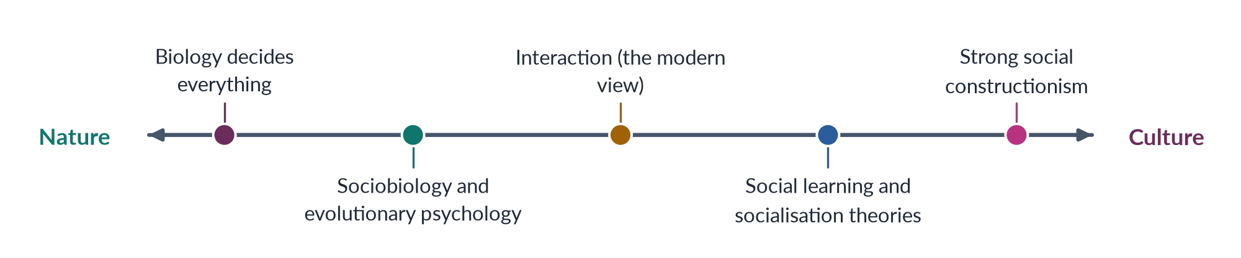
Figure 19 · Positions in the nature–culture debate.
IN SIMPLE WORDS
Nature deals the cards; culture sets the rules of the game. Two players with similar cards can end up very differently depending on the rules — and the rules, unlike the cards, can be changed.

10.6 Why the debate matters — especially for policy
Table 9 · What each side means for policy.
If … | It suggests … | The danger
Differences are mostly natural | Unequal roles cannot be avoided; policy should accept "natural" divisions | It can justify discrimination: "women are not fit for leadership, science or the army"
Differences are mostly cultural | Education, law and social change can remove unfair differences | It can ignore real bodily needs (pregnancy, maternal health, safety)
Nature and culture interact (the evidence) | Remove social barriers and meet bodily needs | —

PAKISTAN ANGLE · THE EVIDENCE FROM PAKISTAN
Pakistan's own experience supports the cultural and interactionist views. Women's literacy has risen from very low levels at independence to about 53% (Census 2023). Girls often top the board examinations. Women now serve as fighter pilots, Supreme Court judges, police officers and a provincial chief minister (since 2024). None of these changes needed a change in biology. They followed changes in education, law, opportunity and attitudes — showing how much of the "natural" order was social all along.

EXAMINER'S EYE · THE 2018 ESSAY: SEX VERSUS GENDER, REFLECTING NATURE VERSUS NURTURE
Structure: (1) introduction — define sex, gender, nature and nurture; (2) the sex/gender distinction (Stoller, Oakley); (3) the nature argument, with evidence; (4) the nurture argument, with evidence (Mead, Baby X, Fine); (5) the David Reimer case — the limits of both extremes; (6) queer theory's question — is sex made too? (Chapter 8); (7) Ortner; (8) interaction; (9) policy and Pakistan; (10) conclusion. Draw the spectrum.

Chapter 11 · The Transgender Debate in Pakistan
In 2026 the examiner asked you to apply social constructionism and queer theory to "contemporary debates about transgender rights and the controversies over the Transgender Persons (Protection of Rights) Act 2018 in Pakistan". This chapter gives you the terms, the history, the law, the court judgment, the arguments — and the balanced view a civil servant should take.

11.1 The terms
Table 10 · The terms of the debate.
Term | Simple meaning
Intersex | Born with a body that does not fit the usual male or female pattern (khuntha in classical Islamic law).
Transgender | A person whose gender identity differs from the sex recorded at birth.
Khawaja sira / hijra | The traditional South Asian terms for gender-variant communities, which have their own structure of gurus (teachers) and chelas (disciples).
Gender identity | A person's inner sense of their own gender.
Gender expression | How a person shows their gender — clothes, speech, behaviour.
Self-perceived (self-identified) gender | Legal recognition of a person's gender based on their own statement, without medical tests.

11.2 History: from the Mughal court to the margins
- Recognition in the past. Khawaja siras held respected roles in Mughal households and courts, as guards, advisers and managers.
- Criminalised under British rule. The Criminal Tribes Act of 1871 labelled "eunuchs" a criminal class, to be registered and watched. The community never fully recovered.
- After independence. Gender-variant people in Pakistan were mostly shut out of education, jobs and inheritance. Many survived by begging, dancing at weddings or sex work, and faced high levels of violence.

11.3 The Supreme Court and recognition (2009)
✦ CASE
Dr Muhammad Aslam Khaki v. SSP (Operations) Rawalpindi · Supreme Court of Pakistan, 2009 onwards
In a series of orders beginning in 2009, the Supreme Court told the government to recognise khawaja siras as citizens with equal rights, to give them a separate gender category on national identity cards, and to protect their rights to inheritance, education, jobs and voting.
➜ Pakistan became one of the first countries to give legal recognition to a third gender — the answer to two 2018 MCQs.

After the judgment, NADRA began issuing identity cards with a separate gender category. Gender-variant people voted and stood as candidates in later elections. The 2017 Census counted 10,418 transgender persons — a number activists said was far too low.

11.4 The Transgender Persons (Protection of Rights) Act 2018
Parliament passed the Act in 2018 with support from all the main parties. Human-rights groups praised it as one of the most progressive laws of its kind. Its main provisions:
✦ LAW & POLICY
Transgender Persons (Protection of Rights) Act 2018 · Pakistan
• Defined intersex, khawaja sira and transgender persons, and "gender identity" as a person's innermost sense of self.
• Section 3: gave a transgender person the right to be recognised by their self-perceived gender identity, and to register it with NADRA and other offices.
• Banned discrimination in education, jobs, health care, transport, housing and public places.
• Section 7: set inheritance rights according to the gender recorded on the identity card.
• Protected the rights to vote, hold public office, gather and get an education; provided protection centres and safe houses; made harassment of transgender persons an offence.
➜ The law joined anti-discrimination protections (widely supported) with self-perceived gender identity (the cause of the later controversy).

11.5 The controversy (2022)
From 2022 the Act became the subject of fierce public debate:
- Critics — including religious parties, some scholars and the Council of Islamic Ideology — argued that letting people change their legal gender by their own statement could be misused, could in effect allow same-sex marriage, and conflicted with Islamic rules on gender and inheritance. Amendment bills were moved in the Senate to require medical boards.
- Supporters — transgender activists, human-rights organisations and many lawyers — argued that critics misrepresented the law, that it protected one of the country's most vulnerable groups, that medical tests are degrading, and that no evidence of widespread misuse had been shown.

11.6 The Federal Shariat Court judgment (2023)
✦ CASE
Federal Shariat Court judgment on the Transgender Act · 19 May 2023
The Court held that the parts on self-perceived gender identity (the definition in section 2(f) and section 3) and the related inheritance section (section 7) were against the injunctions of Islam. It ruled that a person's gender cannot be decided by self-perception alone and must match biological sex. It affirmed that intersex persons and khawaja siras are entitled to all the rights of citizens and to protection from discrimination.
➜ The Court drew a line between intersex variation (recognised, as in classical fiqh) and gender identity separate from biological sex (not recognised).

LATEST UPDATE · THE APPEAL IS PENDING
Appeals against the judgment were filed before the Shariat Appellate Bench of the Supreme Court — the first by former senator Farhatullah Babar in July 2023. As of 2026 the appeals had not been finally decided. Under Article 203D of the Constitution, a Federal Shariat Court decision that is under appeal does not take effect until the appeal is decided. Check the Fact Book for the latest position before your exam.

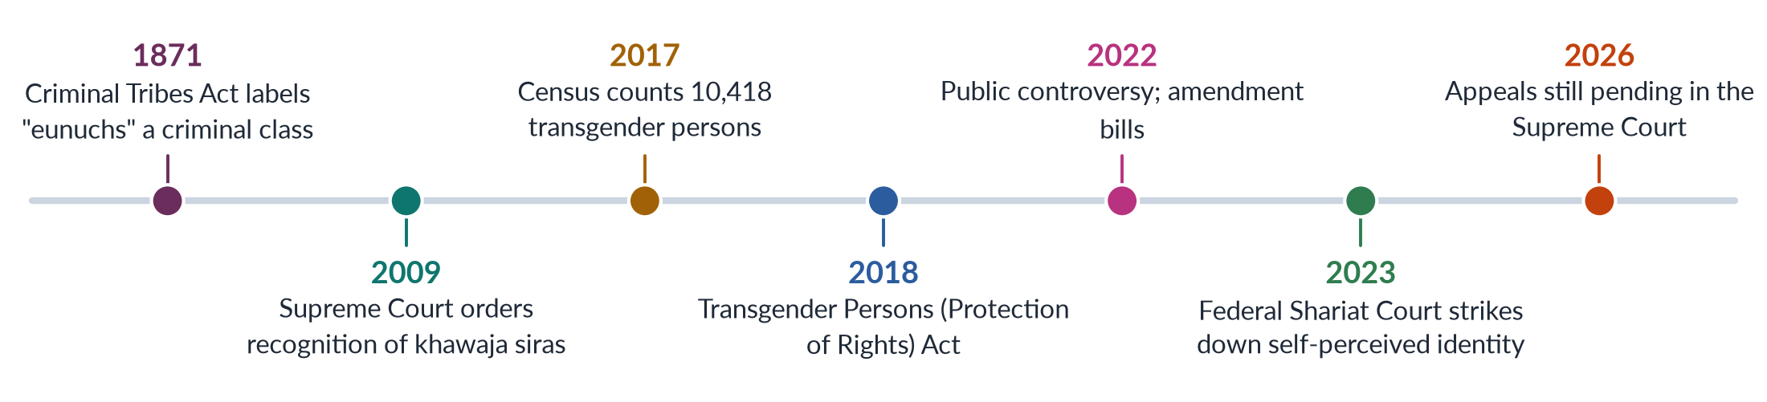
Figure 20 · The transgender question in Pakistan's law.

11.7 What the theories explain
This is the heart of the 2026 question.
Table 11 · How the theories of Topic 1 explain the debate.
Theory | What it says | How it applies to the Act
Sex/gender distinction (Oakley) | Sex is biological; gender is social | Supports protecting gender identity separately from biological sex
Social constructionism | Roles and identities are made in society | Explains khawaja sira identities as real social identities with a long history, not "confusion"
Queer theory (Butler; Sedgwick) | Opposite-pairs are made; identities are performed and fluid | Supports self-identification; challenges the rule that gender must follow sex
The biological view | Sex is two-sided and biological; sorting is not creating | Underlies the critics' view and the Federal Shariat Court's insistence on biological sex
Intersectionality | Disadvantages overlap | Transgender Pakistanis face gender, class and social exclusion together

So the debate repeats, in Pakistan's courts and parliament, the academic argument of Chapter 8: is sex a fixed biological fact on which gender must rest, or is the link between body and identity more complex?
BALANCED VIEW · THE VIEW TO TAKE IN THE EXAM
State the facts neutrally, give both sides fairly, and base your judgement on the Constitution:
1. Dignity and equality (Articles 14 and 25) require that transgender and intersex citizens be protected from violence and discrimination, and have access to education, health, work and inheritance. The Supreme Court (2009), Parliament (2018) and even the Federal Shariat Court (2023) all agree on this.
2. The disputed question — whether legal gender may follow self-perceived identity — involves Article 227 and religious injunctions, and is before the Supreme Court. It should be settled by the courts and by agreement in parliament, informed by evidence, medical ethics and scholarship — not by false claims or street pressure.
3. The practical priority is the protection, livelihood and safety of one of Pakistan's most vulnerable communities, whatever the legal outcome.
➜ This answer shows theory, law and judgement — and it offends no reasonable examiner.

TRAP · TRAPS IN THE TRANSGENDER QUESTION
• Do not confuse intersex (a bodily variation) with transgender (a gender identity). The Federal Shariat Court's judgment turned on exactly this difference.
• Do not say the Act has been "repealed" or "struck down" without explanation — the appeal was pending in 2026.
• Do not use insulting terms. Use khawaja sira, transgender or intersex, as the law does.

Part Two — Today's Debates
The examiner of 2024–2026 wants the topic applied to the present. These are the live debates of Topic 1. Each gives you facts, both sides and a line to take.

Debate 1 · The transgender law and the courts
Covered fully in Chapter 11. The key facts: the Supreme Court recognised khawaja siras in 2009; the Act of 2018 allowed self-perceived identity (section 3) and set inheritance by card gender (section 7); public controversy began in 2022; the Federal Shariat Court ruled against those sections on 19 May 2023; appeals were still pending before the Shariat Appellate Bench in 2026. The line to take: protect dignity and livelihood; let the courts and parliament settle the disputed question.

Debate 2 · The world-wide backlash against "gender"
HOT DEBATE · IS "GENDER" AN IDEOLOGY?
Since the 2010s, movements in Europe, the Americas, Africa and Asia have attacked what they call "gender ideology" — the idea that gender is made by society — as a threat to family, religion and national culture. Some governments have stepped back from gender-equality promises or closed Gender Studies programmes. For example, Hungary removed Gender Studies from its list of approved master's programmes in 2018.
• Critics of the field say it undermines traditional values and biological reality.
• Defenders reply that Gender Studies is a research field like any other; that its findings on violence, health and work rest on evidence; and that closing departments attacks academic freedom.
➜ Link it to Pakistan: similar charges of a "Western agenda" are made here (Chapter 5). The best defence of the field is careful, local, evidence-based research.

Debate 3 · "Masculinity in crisis" and hatred of women online
Young men in many countries — Pakistan included — face unemployment, high prices and changing expectations. Some online influencers sell these young men a return to a dominant, anti-women masculinity. At the same time, online abuse of women journalists, politicians and activists has grown. Masculinity studies (Chapter 9) explains the appeal: when the breadwinner role becomes hard to fulfil, the promise of control over women becomes attractive.
- Researchers' answer: do not simply condemn young men. Offer positive, "caring" models of manhood, economic opportunity, and education on respectful relationships.

Debate 4 · Gender in textbooks
How school textbooks show women and men is a long-running debate in Pakistan. Studies have repeatedly found women shown mainly as mothers and housewives, and men as workers, soldiers and leaders. The Single National Curriculum, introduced from 2021, revived the argument over how girls and women appear in the books.
- One side wants textbooks to show the full range of women's roles — doctors, scientists, pilots, leaders — to widen girls' ambitions.
- Another side stresses cultural and religious values and resists what it sees as foreign influence on the curriculum.
-> The integration plan of Chapter 4 applies directly: gender-aware textbooks are the widest-reaching form of integration.

Debate 5 · The future of Gender Studies departments
Gender Studies departments in Pakistan depend on public university budgets, which are under pressure, and on donor projects that come and go. Yet demand for gender expertise is growing — in government, aid agencies and private companies (for diversity, harassment committees and gender audits). The debate is whether the field can win steady funding and prove its worth through useful, local research.

Debate 6 · Social media and gender rules
Social media has given Pakistani women new voices — businesswomen, teachers, comedians, activists — and new risks: harassment, blackmail and "honour"-based attacks on women who post online. The debate asks whether online platforms are loosening or tightening traditional femininities. Both are happening at once: platforms open space for new femininities while exposing women to new forms of control (Topic 7 covers online violence; Topic 5 the digital gender gap).

Debate 7 · Does Gender Studies matter for Pakistan's development?
BALANCED VIEW · LUXURY OR NECESSITY?
Some say a poor country in economic crisis cannot afford "soft" subjects like Gender Studies. The evidence points the other way. Only 24.4% of Pakistan's working-age women are in the labour force (LFS 2024–25), so most of that half of the population is outside paid work. Closing even part of this gap would add greatly to national income, as many economic studies of South Asia have argued. The data, analysis and policy skills needed to close it — on transport, harassment, childcare, skills and attitudes — are exactly what Gender Studies produces.
➜ Gender Studies is not a luxury for Pakistan; it is part of the toolkit of development (Topic 4) and of good government (Topic 6).

Part Three — The Examiner's Record of Topic 1

Every question, 2016–2026
Table 12 · Every question the examiner has set on T1, 2016–2026.
Year · Q | The question (as set) | Family
2016 · Q2 | Write a note on the status of women's studies in Pakistan and give your views on the autonomy/integration debate in Women's Studies. | Status of Gender / Women's Studies in Pakistan; The autonomy versus integration debate
2016 · Q6 | What are the theories of social construction of gender? | Social construction of gender — theories; deconstructing 'gender'
2017 · Q2 | Define and discuss the discipline of Gender Studies and also differentiate between Women's Studies and Gender Studies. | Gender Studies as a discipline — meaning, need, scope; Women's Studies versus Gender Studies
2017 · Q7 | Write a comprehensive note on the autonomy versus integration debate in Gender Studies. | The autonomy versus integration debate
2018 · Q2 | What are the fundamental differences between Gender Studies and Women's Studies? Substantiate your argument(s) with examples. Highlight the current status of Women's Studies in Pakistan. | Women's Studies versus Gender Studies; Status of Gender / Women's Studies in Pakistan
2018 · Q3 | Write a comprehensive essay on the 'sex versus gender debate' in feminist philosophy and social sciences, reflecting the nature versus nurture argument. | Sex versus gender; is sex socially constructed; nature versus nurture
2019 · Q2 | How do you differentiate the discipline of Gender Studies from that of Women's Studies? Historically trace the need for the establishment of Gender Studies as a distinct discipline and its scope and significance, with special reference to Pakistan. | Gender Studies as a discipline — meaning, need, scope; Women's Studies versus Gender Studies; Status of Gender / Women's Studies in Pakistan
2020 · Q2 | Gender has multiple meanings. How do you deconstruct the word 'GENDER'? | Social construction of gender — theories; deconstructing 'gender'; Sex versus gender; is sex socially constructed; nature versus nurture
2020 · Q4 | 'Language is gendered.' What does this imply? Explain with examples. | Gendered language
2021 · Q2 | Discuss in detail how the autonomy and integration debate in Gender Studies has made an important contribution to the development of the field of knowledge. | The autonomy versus integration debate
2021 · Q3 | Masculinity and femininity are deeply engraved realities since the distant past in human history. Discuss various theoretical debates on their construction to make explicit whether the formation of both is a natural or social reality. Support your arguments with real-life examples. | Masculinities, femininities and gender roles; Sex versus gender; is sex socially constructed; nature versus nurture
2022 · Q2 | Discuss in detail the multidisciplinary nature of Gender Studies. | The multidisciplinary nature of Gender Studies
2023 · Q2 | Write a note on the status of Gender Studies in Pakistan. Give your views on the autonomy versus integration debate in Gender Studies. | Status of Gender / Women's Studies in Pakistan; The autonomy versus integration debate
2023 · Q3 | Differentiate between Gender Studies and Women's Studies. Discuss in detail the multidisciplinary nature of Gender Studies. | Women's Studies versus Gender Studies; The multidisciplinary nature of Gender Studies
2023 · Q4 | Define the terms masculinity and femininity. In your opinion, where do traditional gender roles come from? | Masculinities, femininities and gender roles
2024 · Q8(a) | Short note: Is 'sex' also a social construct? | Sex versus gender; is sex socially constructed; nature versus nurture
2026 · Q2 | Critically examine the theoretical arguments of social constructionism and queer theory regarding the categories of sex and gender. How do these arguments illuminate contemporary debates about transgender rights and the controversies over the Transgender Persons (Protection of Rights) Act 2018 in Pakistan? Support your answer with examples from legal debates and activism. | Queer theory and transgender rights; Social construction of gender — theories; deconstructing 'gender'

What the record reveals
- Sixteen full questions and one short note in eleven papers — the second-heaviest topic, after Gender and Development.
- The discipline half repeats relentlessly. Women's vs Gender Studies (2017, 2018, 2019, 2023), status in Pakistan (2016, 2018, 2019, 2023), autonomy vs integration (2016, 2017, 2021, 2023) and the multidisciplinary nature (2022, 2023). The same four families, recombined.
- The construction half is getting harder. From "what are the theories?" (2016) to "deconstruct gender" (2020), "natural or social?" (2021), "is sex a construct?" (2024) and queer theory applied to Pakistani law (2026).
- Near repeats are common. 2016 Q2 and 2023 Q2 are almost identical (status plus autonomy–integration). Expect a third appearance.
- A three-year silence. No question on the discipline half since 2023 — the longest gap in the record. It is due.

Five likely questions
1. "Trace the historical development of social constructionism in the study of gender. How has it changed our understanding of 'woman'?" (Chapter 6 — the syllabus line never asked by name.)
2. "Critically evaluate the achievements and challenges of Gender Studies as an academic discipline in Pakistan." (Chapter 5, with Chapter 4.)
3. "Is biology destiny? Discuss the nature versus culture debate with reference to gender roles in Pakistani society." (Chapters 9–10.)
4. "Explain Connell's concept of hegemonic masculinity. How does it help explain gender inequality in Pakistan?" (Chapter 9.)
5. "Queer theory argues that even 'sex' is socially constructed. Critically examine this claim." (Chapter 8.)
These are not solved here; the Prediction Papers include answers to predicted questions. Plan each as an answer map for practice.

Part Four — The One-Liner Bank
123 one-liners in the style of the past MCQs, grouped by chapter. Key words, names and dates are in bold. Where a line repeats a past MCQ, the year is given in brackets. Read them the day you finish this Knowledge Base, and again in the last week. After them come all the recovered MCQs on Topic 1 with their keys.

The one-liners

A · The discipline of Gender Studies
1. Gender Studies studies how society makes femininity and masculinity and how this shares out power — it is not "the study of women only".
2. Sex refers to anatomical and physiological differences; gender refers to social and cultural roles (MCQ 2025).
3. "Social and cultural expectations of being male or female" describe a gender role, not sex (MCQ 2025).
4. The belief that "boys should play with trucks" is an example of the social construction of gender (MCQ 2025).
5. The four key ideas in any definition of Gender Studies are: gender is made, it is about power, the field is multidisciplinary, and gender intersects with other identities.
6. Androcentrism means treating men as the normal human and women as the exception.
7. Patriarchy is a hierarchical system dominated by males (MCQ 2023) — literally "rule of the father".
8. Misogyny means hatred of or contempt for women (MCQ 2018).
9. Praxis means joining study with action — a key feature of Gender Studies.
10. Carol Gilligan (In a Different Voice, 1982) found an "ethic of care" in girls that old theories had ranked as weaker.
11. Marilyn Waring (If Women Counted, 1988) showed that GDP ignores unpaid work such as cooking, cleaning and care.
12. "Add women and stir" describes the early, weak method of simply adding women to old subjects without changing their frameworks.
13. Joan Wallach Scott (1986) called gender "a primary way of signifying relationships of power".
14. Feminist research aims at addressing women's issues from women's perspectives (MCQ 2023).
15. The term "interactive methodology" in feminist research was coined by Nancy Kleiber and Linda Light (MCQ 2023).
16. "Subjugation of men" is not an aim of Women's Studies — a trap option in MCQ 2023.
17. Removing caste hierarchy is not an objective of a gender-sensitisation programme (MCQ 2023).
18. Intersectionality — the idea that gender overlaps with class, race and religion — was coined by Kimberlé Crenshaw in 1989.
19. Pakistan acceded to CEDAW in 1996 and has promised SDG 5 (gender equality) by 2030 — both need gender expertise.
20. Pakistan ranked 143rd of 145 in the Global Gender Gap Report 2026 (after 148th of 148 in 2025).

B · Women's Studies and Gender Studies
21. One of the first Women's Studies courses was taught at Cornell University in 1969.
22. The first full Women's Studies programme began at San Diego State College in 1970.
23. The US National Women's Studies Association was founded in 1977.
24. Women's Studies was called "the academic arm of the women's movement".
25. Women's Studies made women the subject, the knowers and the beneficiaries of research.
26. India's report *Towards Equality* (1974) sparked Women's Studies in South Asia.
27. The key difference: Women's Studies studies women; Gender Studies studies gender relations, including men and sexualities.
28. Gayle Rubin (1975) described the "sex/gender system" in her essay "The Traffic in Women".
29. Raewyn Connell's Gender and Power (1987) helped bring men's studies into the field.
30. bell hooks (1981) and Chandra Talpade Mohanty (1984) criticised Women's Studies for treating white, Western women as "all women".
31. Tania Modleski's Feminism Without Women (1991) warned that "gender" could make women invisible again.
32. Many departments use the joint name "Women's and Gender Studies" to keep both the focus on women and the study of relations.

C · The multidisciplinary nature
33. Multidisciplinary means disciplines working side by side; interdisciplinary means mixing their methods into one approach.
34. Transdisciplinary work goes beyond the university, working with activists and communities.
35. Ann Oakley (The Sociology of Housework, 1974) showed that housework is real, unpaid work.
36. Margaret Mead (1935) studied the Arapesh, Mundugumor and Tchambuli of New Guinea.
37. Sherry Ortner (1974) asked "Is Female to Male as Nature Is to Culture?"
38. Michelle Rosaldo (1974) linked women's lower status to their confinement to the domestic sphere.
39. Gerda Lerner wrote *The Creation of Patriarchy* (1986), showing that male rule had a historical beginning.
40. Ester Boserup (Woman's Role in Economic Development, 1970) showed that development ignored women farmers.
41. Carole Pateman wrote *The Sexual Contract* (1988) — the liberal "social contract" hid a contract subordinating women.
42. Catharine MacKinnon (1979) argued that sexual harassment is sex discrimination.
43. Laura Mulvey (1975) coined the "male gaze" in film.
44. Elaine Showalter coined gynocriticism — the study of women writers (MCQ 2024).

D · Autonomy versus integration
45. The autonomy/integration debate was framed by Gloria Bowles and Renate Duelli Klein in *Theories of Women's Studies* (1983).
46. Autonomy means a separate department with its own staff, courses and degrees.
47. Integration (mainstreaming) means adding gender to every subject.
48. The main risk of autonomy is ghettoisation — the field becomes a small, ignored "women's corner".
49. The main risk of integration is dilution — gender reduced to one token lecture.
50. Bowles and Klein argued that integration without an autonomous base would water down feminist study.
51. The usual answer to the debate is the dual strategy: a separate base that drives integration into other subjects.
52. The Beijing Platform for Action (1995) used a "twin-track" approach — mainstreaming plus special measures — the policy version of the dual strategy.
53. Sandra Harding (The Science Question in Feminism, 1986) asked whether "objective" science reflects male viewpoints — a product of the integration debate.
54. In Pakistan, autonomy came first (the 1989 centres) while integration into law, medicine and economics remains weak.

E · Gender Studies in Pakistan
55. Women's Studies centres were set up in five public universities in 1989 by the Ministry of Women's Development.
56. The five universities: Quaid-i-Azam (Islamabad), Karachi, Punjab (Lahore), Peshawar and Balochistan (Quetta).
57. A Centre of Excellence in Gender Studies is housed at Quaid-i-Azam University (MCQ 2016).
58. The *Pakistan Journal of Gender Studies* was the journal named in MCQ 2018.
59. Shirkat Gah (1975) and the Aurat Foundation (1986) did research on women before the university centres.
60. Khawar Mumtaz and Farida Shaheed wrote *Women of Pakistan: Two Steps Forward, One Step Back?* (1987).
61. The National Commission on the Status of Women was set up in 2000.
62. The National Policy for Development and Empowerment of Women was launched in 2002 (MCQ 2018).
63. Gender Studies became a CSS optional subject from CE-2016 (Group V, code 31).
64. Rubina Saigol and Farzana Bari wrote the reviews of Women's Studies in Pakistan on the FPSC reading list.
65. The field's problems are financial (donor funding), intellectual (borrowed theory) and political ("Western agenda" charge).
66. The best answer to the "Western agenda" charge is local research, local theory and local languages.

F · Constructionism and its theories
67. Essentialism holds that women and men have a fixed, natural essence; constructionism holds that gender is made by society.
68. Aristotle described the female as a kind of incomplete male — classic essentialism.
69. Mary Wollstonecraft (1792) argued women's weakness came from lack of education.
70. J. S. Mill (The Subjection of Women, 1869) called women's "nature" "an eminently artificial thing".
71. "One is not born, but rather becomes, a woman" was written by Simone de Beauvoir in *The Second Sex* (1949) (MCQs 2016, 2019, 2024, 2025).
72. Beauvoir argued that society treats woman as "the Other".
73. John Money first used the term "gender role" in 1955.
74. Robert Stoller (Sex and Gender, 1968) separated biological sex from gender identity.
75. Ann Oakley (Sex, Gender and Society, 1972) brought the sex/gender distinction into sociology.
76. Berger and Luckmann wrote *The Social Construction of Reality* (1966): externalisation, objectivation, internalisation.
77. Harold Garfinkel (1967) studied "Agnes", showing gender is an ongoing accomplishment.
78. Foucault's History of Sexuality (1976) argued that power produces discourse on sexuality, rejecting the "repressive hypothesis" (MCQ 2026).
79. "Doing Gender" (1987) was proposed by West and Zimmerman (MCQ 2026).
80. Judith Butler wrote *Gender Trouble* (1990) (MCQ 2019) and argued gender is performative (MCQ 2024).
81. Performativity means gender is constituted through repeated acts, not an inner reality — "None of these" was the key in MCQ 2026.
82. Judith Lorber (Paradoxes of Gender, 1994) described gender as a social institution.
83. Kohlberg's three stages: gender identity (2–3), stability (4–5), constancy (6–7).
84. Sandra Bem proposed gender schema theory (1981); Bandura and Mischel stand for social learning theory.

G · The meanings of "gender" and gendered language
85. Deconstruction — exposing hidden rankings in pairs of opposites — comes from Jacques Derrida (1967).
86. The word "gender" comes from the Latin *genus* ("kind").
87. "Gender" has at least eight meanings: grammar, sex, roles, identity, performance, institution, power, policy label.
88. Barbara Risman (2004) called gender a social structure working at individual, interaction and institution levels.
89. Robin Lakoff wrote *Language and Woman's Place* (1975) — women taught hedges and tag questions.
90. Dale Spender wrote *Man Made Language* (1980) — men control the meaning of words.
91. Deborah Tannen (1990) contrasted women's "rapport talk" with men's "report talk".
92. Muriel Schulz (1975) described the semantic derogation of women's words (master/mistress; bachelor/spinster).
93. "Mankind" and "chairman" are examples of the generic masculine.
94. "Lady doctor" is a marked female term — it treats the woman as the exception.
95. Pakistan's 2016 law speaks of crimes "in the name or pretext of honour", calling honour an excuse, not a justification.

H · Queer theory and "sex"
96. The term "queer theory" was coined by Teresa de Lauretis (1990–91).
97. Queer theory is not "a new term for gays and lesbians" — the incorrect statement in MCQ 2023.
98. Eve Kosofsky Sedgwick wrote *Epistemology of the Closet* (1990).
99. Heteronormativity is the assumption of two opposite genders and that only heterosexuality is normal.
100. Thomas Laqueur (Making Sex, 1990) described Europe's shift from a one-sex to a two-sex model.
101. Anne Fausto-Sterling wrote "The Five Sexes" (1993) and Sexing the Body (2000).
102. Estimates of intersex births range from about 0.018% (Sax) to 1.7% (Fausto-Sterling), depending on the definition.
103. Butler suggested that "sex" may be "always already gender".
104. Classical Islamic law recognised the intersex person as *khuntha*.

I · Masculinities and femininities
105. Hegemonic masculinity was coined by R. W. (Raewyn) Connell (MCQs 2018, 2023, 2026).
106. Connell's four masculinities: hegemonic, complicit, marginalised, subordinated.
107. The patriarchal dividend is the advantage all men gain from women's subordination (Connell).
108. Emphasised femininity is femininity built around accommodating men.
109. An androgynous person has both masculine and feminine traits (MCQ 2023) — positive traits of both (MCQ 2024).
110. Sandra Bem measured androgyny with the Bem Sex-Role Inventory (1974).
111. Engels (1884) called women's subordination "the world historical defeat of the female sex".
112. Boserup's plough thesis: plough farming produced sharper gender roles (supported by Alesina, Giuliano and Nunn, 2013).

J · Nature versus culture
113. The evolutionary neuroandrogenic theory (Lee Ellis) holds that gender differences in crime are universal (MCQ 2018).
114. In "Baby X" studies (Condry and Condry, 1976), adults saw a crying baby as "angry" if told it was a boy, "afraid" if a girl.
115. Cordelia Fine wrote *Delusions of Gender* (2010); Daphna Joel (2015) described the brain as a "mosaic".
116. The David Reimer case (injured 1966) shows the limits of the "pure nurture" view.
117. Most scholars today take an interactionist view: biology gives tendencies, culture shapes them.

K · The transgender debate
118. The Supreme Court directed recognition of a third gender on CNICs in December 2009 (MCQ 2018).
119. Pakistan is a country that legally recognises a third gender (MCQ 2018).
120. The British Criminal Tribes Act (1871) labelled "eunuchs" a criminal class.
121. The 2017 Census counted 10,418 transgender persons.
122. The Transgender Persons (Protection of Rights) Act was passed in 2018; section 3 allowed self-perceived gender identity.
123. The Federal Shariat Court held sections 2(f), 3 and 7 of the Act against Islamic injunctions on 19 May 2023; appeals remained pending in 2026.

Every past MCQ on Topic 1
Table 13 · Every recovered MCQ on T1, with its key.
Year | Question | Key
2016 · 6 | Which university houses a Centre of Excellence in Gender Studies? | A - Quaid-i-Azam University
2018 · 2 | The belief that gender differences are universal is called: | C - Evolutionary Neuroandrogenic Theory
2018 · 6 | The term for hatred of women is: | A - Misogyny
2018 · 8 | Who coined the term hegemonic masculinity? | A - R. W. Connell
2018 · 10 | The Supreme Court directed recognition of a third-gender identity in CNICs in: | A - December 2009
2018 · 11 | Which country legally recognizes a third gender? | C - Pakistan
2018 · 14 | The only academic journal on Gender Studies in Pakistan listed here is: | D - Pakistan Journal of Gender Studies
2019 · 10 | Gender Trouble was written by: | A - Judith Butler
2023 · 2 | Which is not related to Women's Studies? | A - Subjugation of men
2023 · 4 | Which is not an objective of a gender-sensitization programme? | B - Removal of caste hierarchy
2023 · 5 | Mark the correct statement about Gender Studies: | C - Both A and B
2023 · 8 | A person having both masculine and feminine traits is: | A - Androgynous
2023 · 9 | A hierarchical system dominated by males is: | C - Patriarchy
2023 · 11 | Who coined hegemonic masculinity? | A - R. W. Connell
2023 · 13 | Feminist research aims at: | B - Addressing women's issues from women's perspectives
2023 · 18 | Which is incorrect about Queer Studies? | B - A new term for gays and lesbians
2023 · 19 | Who coined 'interactive methodology' for feminist research? | A - Nancy Kleiber and Linda Light
2024 · 4 | Butler proposed that gender is: | C - Performative
2024 · 15 | Traits of an androgynous person: | B - Positive masculine and feminine
2024 · 19 | Which is socially constructed? | C - Both A and B
2024 · 20 | Who said, 'One is not born, but rather becomes a woman'? | A - Simone de Beauvoir
2025 · 2 | 'Social and cultural expectations' of being male or female describe: | C - Gender role
2025 · 4 | Which is an example of a social construction of gender? | C - The notion that boys should play with trucks
2025 · 6 | Gender specialists use 'sex' for: | A - Anatomical and physiological difference
2026 · 1 | Judith Butler's concept of performativity argues that gender is not an internal reality but: | D - None of these; gender is constituted through repeated acts
2026 · 4 | Foucault's History of Sexuality challenges the repressive hypothesis by suggesting: | C - Power produces discourse on sexuality
2026 · 7 | Hegemonic masculinity is attributed to: | A - R. W. Connell
2026 · 17 | 'Doing Gender' was proposed by: | C - West and Zimmerman

TRAP · TWO MCQ TRAPS FROM THE RECORD
• 2026 Q1 asked what Butler's performativity means. The correct answer ("gender is constituted through repeated acts") was not among the options, so the key was "None of these". Know the idea, not just the name.
• 2023 Q18 asked which statement about Queer Studies is incorrect: the answer is "a new term for gays and lesbians". Queer theory questions all categories, including the "normal" ones.

Part Five — The Revision Sheet
The whole of Topic 1 on a few pages, for the night before the exam. Every term is given with its meaning, every thinker with their idea, and every date with its event — so this sheet makes sense on its own, without going back to the chapters.

1. What Gender Studies is
- Gender Studies — the study of how society makes femininity and masculinity, how this shares out power, money and chances, and how gender mixes with class, religion, race, age, disability and sexuality. It uses many disciplines.
- Sex — body differences (chromosomes, hormones, organs). Gender — the roles, behaviour and power society attaches to sex.
- Scope (what it covers) — identity and the body; family and home (marriage, care, inheritance, violence at home); work and economy (paid and unpaid work, pay gap); politics and law; culture (religion, language, media, education); violence; global changes (colonialism, globalisation, migration, climate).
- Aims — make the invisible visible; explain inequality (not just describe it); question what looks "natural"; produce complete knowledge; guide policy; empower. Praxis = joining study with action.
- Why the discipline was needed — four blind spots:
- Androcentrism (treating men as the normal human) — e.g. Carol Gilligan (In a Different Voice, 1982): theories built on boys ranked girls' "ethic of care" (moral thinking based on relationships) as weaker.
- Uncounted work — Marilyn Waring (If Women Counted, 1988): GDP (a country's measured income) ignores unpaid cooking, cleaning and care.
- Unanswered questions from the women's movement (pay, violence, power).
- "Add women and stir" — adding a chapter on women without changing old frameworks — was not enough.
- Features — uses many disciplines; committed to justice; questions who makes knowledge; looks at intersectionality (overlapping disadvantages); compares societies.
- Joan Scott (1986) — gender is "a primary way of signifying relationships of power" = a main way of showing who rules whom.
- Significance — academic (complete knowledge); policy (CEDAW = UN women's rights treaty, Pakistan joined 1996; SDG 5 = gender equality by 2030; gender budgeting = checking a budget's effect on women and men); social (words for hidden harms); Pakistan (143rd of 145, Global Gender Gap 2026; women in labour force 24.4%, LFS 2024–25; women's literacy about 53%, Census 2023).

2. Women's Studies versus Gender Studies
- Women's Studies — the field that puts women at the centre of study. Called "the academic arm of the women's movement". Women as subject (studied), knowers (their experience counts) and beneficiaries (research helps them).
- Origins — first course at Cornell (1969); first programme at San Diego State (1970); US National Women's Studies Association (1977); India's report *Towards Equality* (1974).
- Why it became Gender Studies (1980s–90s) — (1) the idea of gender grew: Oakley (1972), Rubin's "sex/gender system" (1975 — how society turns biological sex into social roles), Scott (1986); (2) men's studies: Connell, Gender and Power (1987); (3) queer theory (c. 1990); (4) critics said "woman" meant only white Western women: bell hooks (1981), Mohanty (1984); (5) aid agencies moved from WID to GAD.
- Differences —
- Subject: WS = women; GS = gender relations (women, men, gender-diverse people).
- Key idea: WS = "woman" and oppression; GS = gender as made by society and a relation of power.
- Origin: WS = late 1960s movement; GS = 1980s–90s theory.
- Aim: WS = make women visible, end subordination; GS = explain the whole gender system.
- Politics: WS = woman-centred feminist; GS = wider, includes masculinities and sexualities.
- Viewpoint: WS = by and for women; GS = many viewpoints including men's.
- Theories: WS = liberal, radical, socialist feminism; GS = adds constructionism, queer theory, intersectionality.
- Pakistan: WS = the 1989 centres; GS = today's departments.
- Examples — honour killing: WS studies the victims and failures of justice; GS also studies *ghairat* (honour), manhood, family bargaining over "forgiveness", and the law until the 2016 amendment. Maternal health: WS = women's experience; GS = also husbands' and mothers-in-law's control over clinic visits.
- Shared — feminist roots; rejection of male-centred knowledge; many disciplines; aim of change.
- Relationship — growth / dilution (Tania Modleski, Feminism Without Women, 1991: "gender" can hide women again) / partnership ("Women's and Gender Studies"). Line to take: partners in one project.

3. The multidisciplinary nature
- Multidisciplinary = several disciplines side by side. Interdisciplinary = disciplines mixed into one approach (e.g. care economy, intersectionality, gender budgeting). Transdisciplinary = work beyond the university with communities.
- Why many disciplines — gender is everywhere; problems are complex (Pakistan's 24.4% women's labour participation needs economics, sociology, law, transport planning, psychology, politics); founders came from many subjects; to criticise a discipline you must work inside it.
- What each adds:
- Sociology — roles are made by society; Ann Oakley, The Sociology of Housework (1974): housework is real, unpaid work.
- Anthropology — gender differs by culture; Margaret Mead (1935): Arapesh (both sexes gentle), Mundugumor (both fierce), Tchambuli (women in charge); Sherry Ortner (1974): women linked with "nature", men with "culture"; Michelle Rosaldo (1974): women's confinement to the home.
- Psychology — identity; Sandra Bem (1974): androgyny (having both masculine and feminine traits); Gilligan (1982).
- History — "her-story"; Gerda Lerner, The Creation of Patriarchy (1986): male rule had a beginning.
- Economics — Ester Boserup (1970): development ignored women farmers; Waring (1988); feminist economics and time-use surveys.
- Political science — Carole Pateman, The Sexual Contract (1988): the "social contract" hid women's subordination.
- Law — Catharine MacKinnon (1979): sexual harassment is sex discrimination; CEDAW (1979); Pakistan's harassment law (2010).
- Biology and medicine — sex, intersex, women's health; Pakistan: 186 maternal deaths per 100,000 live births (2019).
- Literature, language, media — Elaine Showalter: gynocriticism (studying women writers); Robin Lakoff (1975); Laura Mulvey (1975): the "male gaze" (films made as if for a male viewer).
- Development and religious studies — WID → GAD; Moser, Kabeer; Amina Wadud, Fatima Mernissi (re-reading Islamic texts).
- Strengths — full picture; new ideas; useful for policy; many methods. Weaknesses — "no core"; single-discipline teachers; number vs story methods; no clear home → the autonomy debate.

4. Autonomy versus integration
- Source — Gloria Bowles and Renate Duelli Klein, *Theories of Women's Studies* (1983) (on the FPSC reading list). They said integration without a separate base waters down feminist study.
- Autonomy = Gender Studies as a separate department with its own teachers, courses, degrees, budget and research ("a house of its own").
- For: room for new theory; depth (degree to PhD); protection from being dropped; respect and visibility; independent critical voice; a home for researchers and activists.
- Risk: ghettoisation = being pushed into a small, ignored "women's corner"; costly; donor-dependent.
- Integration (mainstreaming) = adding gender to every subject — law, medicine, economics ("changing everyone else's house").
- For: gender matters to all subjects; reaches every student; avoids the ghetto; changes the subjects themselves; cheaper; involves men.
- Risk: dilution = gender reduced to one token lecture ("add a lecture and stir"); depends on a few teachers; loss of expertise.
- The answer — dual strategy = a separate centre that trains specialists and carries gender into other departments (trains their teachers, shares their courses). Policy version: Beijing Platform (1995) "twin track" = gender mainstreaming (checking every policy for its effect on women and men) plus special measures and women's ministries.
- What the debate gave the field (2021) — (1) a clear identity: a subject and a critique of all knowledge; (2) feminist epistemology (how we know) — Sandra Harding (1986): is science truly objective or male-biased?; (3) institutions — departments, degrees, journals, NWSA; (4) curriculum transformation (rewriting courses, 1980s); (5) a model for gender mainstreaming; (6) self-criticism, which opened the field to Black, postcolonial and queer critics. Limits: rivalry; token integration; donor dependence.
- Pakistan — autonomy first (1989); integration weak. Plan: medicine (maternal health), law (family law, inheritance, pro-women laws), economics (unpaid care, gender budgeting), education (textbooks), engineering and planning (safe transport, toilets), civil-service training. Local integration also answers the "Western agenda" charge.

5. Gender Studies in Pakistan
- Before the universities — Shirkat Gah (1975) and the Aurat Foundation (1986): research on women's rights and work; Women's Action Forum (1981): challenged the Hudood Ordinances (1979 laws on sexual offences that harmed women); Mumtaz and Shaheed, Women of Pakistan (1987): first history of the movement.
- 1989 — the Ministry of Women's Development set up Women's Studies centres at Quaid-i-Azam University (Islamabad), Karachi, Punjab (Lahore), Peshawar and Balochistan (Quetta). Centre of Excellence in Gender Studies = QAU (MCQ 2016). Most later renamed "Gender Studies".
- Achievements — degrees to PhD; research on violence, law, politics, work, health; journals (Pakistan Journal of Gender Studies; Alam-e-Niswan); trained staff for the National Commission on the Status of Women (2000) and commissions; policy input — National Policy for Development and Empowerment of Women (2002), Gender Reform Action Plan (early 2000s); evidence for laws on harassment (2010), acid (2011), honour killing (2016), violence at home (Punjab 2016; Islamabad 2025); CSS subject from CE-2016.
- Problems — three kinds — financial (short donor projects); intellectual (Western books, little local theory, mostly English, weak data); political (resistance; "Western/anti-family agenda"). Also: few trained teachers; ghettoisation; weak policy links; poor libraries outside cities; no integration.
- "Western agenda" reply — local roots of women's activism; Pakistani problems measured with Pakistani data; Muslim scholars' own gender scholarship.
- Way forward — steady HEC funding; PhD training; local research, theory and Urdu books; integration (dual strategy); links with NCSW, Bureau of Statistics, Women's Parliamentary Caucus; involve men; research on minority, rural and disabled women.

6. Constructionism and its theories
- Essentialism = women and men have a fixed natural essence (Aristotle: the female as an incomplete male; Victorian science). Social constructionism = gender is made by society (upbringing, language, institutions, law, religion, daily life). Historicizing constructionism = telling the history of this idea.
- The history in one line — Wollstonecraft (1792: weakness from lack of education) → Mill (1869: women's "nature" is "an eminently artificial thing") → Mead (1935: three societies) → Beauvoir (1949: "One is not born, but rather becomes, a woman"; woman as "the Other") → Money (1955: coined "gender role") → Berger and Luckmann (1966) → Garfinkel (1967: "Agnes" — gender is a daily achievement) → Stoller (1968: sex vs gender identity) → Oakley (1972: sex biological, gender cultural) → Rubin (1975) → Foucault (1976: power produces talk about sexuality) → Kessler and McKenna (1978: we assign gender from clues) → West and Zimmerman (1987) → Butler (1990) → Lorber (1994).
- Berger and Luckmann (The Social Construction of Reality, 1966) — externalisation (people create arrangements) → objectivation (they look like solid facts) → internalisation (new generations learn them as natural).
- The seven theories of how gender is made:
1. Psychoanalytic — Freud: child copies the same-sex parent; Chodorow (1978): because mothers do the childcare, girls learn to care and boys learn to separate — mothering reproduces gender.
2. Social learning — Bandura, Mischel (1966): reward, punishment and copying ("brave like a man").
3. Cognitive-developmental — Kohlberg (1966): child works gender out in stages — identity (2–3: "I am a girl"), stability (4–5: "I will be a woman"), constancy (6–7: "I stay a girl whatever I wear").
4. Gender schema — Bem (1981): a mental map sorts things into "for boys" and "for girls" and filters what the child notices.
5. Doing gender — Goffman (1979: gender displayed in poses); West and Zimmerman (1987): gender is done in daily interaction and people are judged for doing it "wrong".
6. Performativity — Butler (1990): repeated acts create the appearance of a gender inside us; repeat differently and gender changes.
7. Structural — Lorber (1994: gender as an institution); Connell (a gender order of power, work and feeling); Risman (2004: gender as a social structure at individual, interaction and institution levels).
- Agents in Pakistan — family (freedom for boys, housework for girls); school (textbooks); religion and community; media (dramas, adverts); state and law (male head of household).
- Critique — ignores the body; makes people look passive; relativism (if all is made, what is unjust?); male dominance is widespread; too abstract (Nussbaum, 1999). Answer: interaction — biology gives raw material, society builds roles.

7. Deconstructing "gender" and gendered language
- Deconstruction — Jacques Derrida (1967): thinking is built on pairs of opposites (reason/emotion, culture/nature, public/private) where one side is ranked higher; deconstruction exposes the ranking. Feminists note the "higher" side is linked with men.
- "Gender" comes from Latin *genus* ("kind"). Eight meanings: (1) grammar (Urdu kitaab feminine, qalam masculine); (2) a polite word for sex; (3) social roles (Oakley); (4) identity — inner sense of self (Stoller); (5) performance — something we do (West and Zimmerman; Butler); (6) institution/structure (Lorber; Risman); (7) relation of power (Scott); (8) policy label — mainstreaming, budgeting (risk: loses political meaning).
- The masculine/feminine pair — reason/emotion, strength/weakness, culture/nature, public/private, independence/dependence, leadership/obedience. It is ranked (masculine valued and paid more), not natural (everyone has both — androgyny), unstable (changes with time and place).
- "Language is gendered" means language reflects, passes on and can change the gender ranking. Theory: language shapes thought (moderate Sapir–Whorf); Robin Lakoff (Language and Woman's Place, 1975: women taught hedges like "sort of" and tag questions like "isn't it?"); Dale Spender (Man Made Language, 1980: men control word meanings — e.g. no word for "sexual harassment" before the 1970s).
- Forms, with examples — generic masculine (male words for all: "mankind", "chairman"; Urdu masculine plural for mixed groups); marked terms (woman as exception: "lady doctor", "actress"); semantic derogation (women's words lose respect — master/mistress, bachelor/spinster; Muriel Schulz, 1975); insults and sayings ("choorian pehen lo" = put on bangles, i.e. coward; "aurat ki aql" = woman's wit, i.e. foolishness; "zan, zar, zameen" = women, gold, land as causes of fights); names ("Mrs"; "ghar wali"); excusing violence ("honour" killing; "she provoked him"; "eve-teasing"); talk patterns (men interrupt — Zimmerman and West, 1975; "rapport talk" vs "report talk" — Tannen, 1990).
- Effects — invisibility; stereotypes; lower value; violence made normal; silencing.
- Change — inclusive words (chairperson, humankind); UN guidelines; new words (harassment, femicide, glass ceiling); Pakistan: harassment Act (2010), "in the name or pretext of honour" (2016), khawaja sira (2018); "Aurat March" makes aurat a word of pride. Caution: words alone are not enough.

8. Queer theory and "sex"
- Problematizing sex = asking whether "sex" is really a simple natural fact, or partly shaped by society.
- Queer theory (c. 1990) — from AIDS activism and Queer Nation (1990, which reclaimed "queer" from an insult) and from scholars: Teresa de Lauretis coined the term (1990–91); Judith Butler, Gender Trouble (1990); Eve Sedgwick, Epistemology of the Closet (1990); built on Foucault (1976). Not "a new term for gays and lesbians" (MCQ 2023).
- Claims — categories have a history (Foucault: "the homosexual" as a type of person was a 19th-century medical idea); heteronormativity (assuming two opposite genders and that only heterosexuality is normal); identities are fluid and performed; take apart pairs of opposites; study the edges to see how the norm is made.
- Yes, sex is partly made — Laqueur (Making Sex, 1990): Europe moved from a one-sex model (female body as an inside-out male body) to a two-sex model in the 18th century, partly for social reasons; intersex variation (bodies not fitting the usual pattern) — estimates 0.018% (Sax, 2002) to 1.7% (Fausto-Sterling) depending on definition; doctors assigned intersex babies by social tests; sports keep changing sex tests (Semenya); Butler: sex may be "always already gender" (we see bodies through gender categories).
- No, sex is biological — reproduction needs two kinds of cells (eggs and sperm); most people fit clearly; sorting bodies is not creating them; real consequences (pregnancy, women's sport, women-only spaces); too abstract (Nussbaum).
- Middle position — bodies are real; how we sort them and what they mean is social. Islamic law: the intersex person = *khuntha*, with detailed rules — variation recognised within a two-sex framework; hijras/khawaja siras had roles at the Mughal court.
- Evaluation — adds: history of categories, exposes heteronormativity, visibility for intersex and gender-diverse people, case for change. Critics: abstract, Western, may dissolve "women", may ignore poverty and health.

9. Masculinities and femininities
- Masculinity = behaviour and ideals society expects of men (strength, courage, hiding emotion, providing, authority). Femininity = behaviour and ideals society expects of women (modesty, care, beauty, obedience, sacrifice). Both are plural, relational (defined against each other), ranked and changeable.
- Connell (Gender and Power, 1987; Masculinities, 1995) — every society has a gender order (a pattern of power among masculinities and femininities).
- Hegemonic masculinity = the most honoured way of being a man; justifies men's power over women and other men. "Hegemony" (from Gramsci) = rule through consent and admired ideals.
- Complicit = most men, who do not match the ideal but gain from it — the patriarchal dividend (the advantage all men get from women's subordination).
- Marginalised = men placed lower by class, ethnicity or race.
- Subordinated = men looked down on as "unmanly" (gay, effeminate, many khawaja siras).
- Emphasised femininity = femininity built around pleasing and serving men; honoured but never on top.
- Pakistani ideals — the *ghairat-mand* (honour-bound) man who controls "his" women; mockery of the *joru ka ghulam* ("wife's slave"); the *sharif aurat* (respectable woman) who guards *izzat* (honour); beauty rules (fair skin); the double burden (earning plus all housework).
- Natural or social? (2021) — biological/evolutionary (testosterone; E. O. Wilson, 1975) = mainly natural; psychoanalytic (Freud; Chodorow) = social but deep; learning and cognitive (Bandura; Kohlberg; Bem) = social; Connell = social and political; performative (Butler) = social and changeable. Evidence: Mead's three societies; change over history (World Wars; warrior vs Sufi ideals of manhood); change in Pakistan. Verdict: interaction — biology gives tendencies, but the form and ranking are social.
- Where traditional roles come from (2023) — (1) biology and childbirth (a starting point, not destiny); (2) economy — Boserup (1970): plough farming made sharper gender roles; Alesina, Giuliano and Nunn (2013) confirmed it; factories created the "breadwinner" ideal; (3) property — Engels (1884): men controlled women to pass property to their sons — "the world historical defeat of the female sex"; (4) religion and culture (interpretations, honour codes); (5) law, state and colonialism (Victorian ideals of women at home; chador aur chaar-diwari in the 1980s); (6) upbringing and media. These sources support each other.
- Costs of the dominant masculinity — violence against women; men's poor health; breadwinner shame; hidden feelings ("*mard ko dard nahi hota*" = a man feels no pain); hostility to difference. Change: caring fathers; HeForShe (UN Women, 2014).

10. Nature versus culture
- Nature vs culture (nurture) = do gender differences come from biology (genes, hormones, brain, evolution) or from society (upbringing, expectations)? Gender development = how a child comes to have a gender identity and role.
- Nature side — hormones (testosterone); CAH girls (exposed to male hormones before birth) prefer boys' toys on average (Berenbaum and Hines, 1992–); average differences in strength and physical aggression; sociobiology (Wilson, 1975) and evolutionary psychology (Buss); evolutionary neuroandrogenic theory (Lee Ellis: evolution and male hormones explain men's higher violent crime everywhere — MCQ 2018).
- Culture side — Mead (1935); change over history (women's work in the World Wars; women now most university students in many countries); "Baby X" (Condry and Condry, 1976: the same crying baby seen as "angry" if called a boy, "afraid" if called a girl); socialisation; the brain changes — Cordelia Fine, Delusions of Gender (2010); Daphna Joel (2015): brains are a "mosaic", not male or female.
- David Reimer — injured in 1966; raised as a girl on John Money's advice; never felt female; lived as male from his teens; died 2004. Lesson: neither pure nurture nor forcing a gender on a person.
- Sherry Ortner (1974) — every culture ranks culture above nature and links women with nature (bodies, home) → women ranked lower; this link is itself cultural.
- Interaction (modern view) — biology gives tendencies; culture shapes, strengthens or reverses them; each affects the other. Policy: remove social barriers and meet bodily needs (maternal health). Pakistan: literacy ~53%, women judges, pilots, a chief minister (2024) — change without any change in biology.

11. The transgender debate
- Terms — intersex (body does not fit the usual pattern; khuntha); transgender (gender identity differs from sex recorded at birth); *khawaja sira / hijra* (traditional South Asian gender-variant communities with guru–chela, teacher–disciple, structure); gender identity (inner sense of gender); gender expression (how gender is shown); self-perceived gender (legal gender based on one's own statement).
- History — respected roles at the Mughal court → British Criminal Tribes Act 1871 labelled "eunuchs" criminal → exclusion after 1947.
- 2009 — Supreme Court (Dr Muhammad Aslam Khaki case): recognise khawaja siras as equal citizens; separate gender category on CNICs (December 2009); rights to inheritance, education, jobs, vote. Census 2017: 10,418 transgender persons (activists: an undercount).
- 2018 Act — Transgender Persons (Protection of Rights) Act: definitions; section 3 = right to self-perceived gender identity and NADRA registration; bans discrimination (education, jobs, health, transport, public places); section 7 = inheritance by the gender on the CNIC; rights to vote and hold office; protection centres; harassment an offence.
- 2022 controversy — critics (religious parties, Council of Islamic Ideology): possible misuse, same-sex marriage "in effect", conflict with Islamic rules on gender and inheritance; bills for medical boards. Supporters: law misrepresented, medical tests degrading, no evidence of misuse.
- Federal Shariat Court, 19 May 2023 — sections 2(f), 3 and 7 held against Islamic injunctions; gender must match biological sex; intersex persons and khawaja siras keep all citizens' rights. Line drawn between intersex variation (recognised) and identity separate from sex (not recognised).
- Appeal — before the Shariat Appellate Bench of the Supreme Court (first by Farhatullah Babar, July 2023); pending in 2026. Article 203D: an FSC decision under appeal does not take effect until the appeal is decided.
- Theories applied (2026) — constructionism → identity is real (supports section 3); queer theory → self-identification over medical tests; biological view → the FSC's biological sex; intersex variation → accepted by all sides.
- Balanced view — Article 14 (dignity) and Article 25 (equality): protection, education, health, work, inheritance — agreed by the SC (2009), Parliament (2018) and FSC (2023). The disputed question (legal gender by self-perception) involves Article 227 (laws must conform to Islam) — to be settled by courts and parliamentary agreement on evidence. Traps: intersex ≠ transgender; the Act is not simply "repealed"; use respectful terms.

The five answer frames that repeat
Frame | Headings in order
Define and differentiate | Introduction (definitions, origin, thesis) → Women's Studies → Gender Studies → differences table → two examples → shared ground → relationship (partners) → conclusion
Status in Pakistan | Introduction → history (NGOs; 1989 centres) → institutions today → achievements → problems (or strengths–weaknesses–opportunities–threats) → way forward → (the debate, if asked) → conclusion
Autonomy vs integration | Introduction → origin (Bowles and Klein 1983) → autonomy: meaning and case → integration: meaning and case → risks (ghettoisation vs dilution) → dual strategy → what the debate gave the field → Pakistan → view and conclusion
Theories of construction | Introduction (essentialism vs constructionism; Beauvoir) → seven theories, each with thinker, how it works and an example → agents in Pakistan → critique → conclusion (interaction)
Natural or social? | Introduction and thesis → biological view → psychoanalytic → learning and cognitive → Connell → performative → evidence from cultures and history → Pakistan → verdict → conclusion

Ten pieces of evidence for any Topic 1 answer
1. Beauvoir (1949): "One is not born, but rather becomes, a woman."
2. Oakley (1972): sex is biological; gender is cultural.
3. Mill (1869): women's "nature" is "an eminently artificial thing".
4. Mead (1935): Arapesh, Mundugumor, Tchambuli — temperament varies by culture.
5. Scott (1986): gender is "a primary way of signifying relationships of power".
6. Bowles and Klein (1983): the autonomy/integration debate.
7. Connell (1987, 1995): hegemonic masculinity; the patriarchal dividend.
8. Butler (1990): gender is performative; sex may be "always already gender".
9. Pakistan 1989: Women's Studies centres at QAU, Karachi, Punjab, Peshawar, Balochistan.
10. Transgender Act 2018 → FSC judgment 19 May 2023 → appeal pending (2026).

